PyHEARTS: Beat-by-beat ECG waveform morphology mapping for interpretable machine learning and AI

Morgan Fitzgerald^{3*}, Eena Kosik¹, Jamie Burks⁵, Ryan Hammonds², Kenton Guarian¹, Mattheus Ramsis⁶, Gregory K. Feld⁶, Ulrika Birgersdotter-Green⁶, Vineet Augustine⁷, Bradley Voytek¹⁻⁴

¹Department of Cognitive Science, University of California, San Diego, La Jolla, CA, USA, ²Halıcıoğlu Data Science Institute, University of California, San Diego, La Jolla, CA, USA, ³Neurosciences Graduate Program, University of California, San Diego, La Jolla, CA, USA, ⁴Kavli Institute for Brain and Mind, University of California, San Diego, La Jolla, CA, USA, ⁵Department of Bioengineering, University of California, San Diego, La Jolla, CA, USA 92093, ⁶Division of Cardiology, Department of Medicine, University of California San Diego, San Diego, CA, USA, ⁷Department of Neurobiology, University of California, San Diego, CA, USA

*e-mail: mofitzgerald@health.ucsd.edu

Data availability
Code is available on GitHub: https://github.com/PyHEARTS-toolbox/pyhearts

Acknowledgements

We are grateful to members of the Voytek Lab for their input throughout this project and for helpful discussions during development and validation of the PyHEARTS framework.

Funding
This work was supported by the NIH Brain Behavior Quantification and Synchronization (BBQS) grant NIH R61MH135109.

Author contributions
M.F. and B.V. conceived the project and developed the analysis framework. M.F. wrote the analysis code and performed all primary analyses. E.K., J.B., and R.H. contributed to feature engineering, signal processing, and validation. K.G. contributed to initial algorithm development and code base. M.R., G.K.F., and U.B.-G. contributed clinical expertise and interpretation. V.A. provided mouse data and murine cardiac expertise. M.F. and B.V. wrote the manuscript; all authors reviewed and edited the manuscript.

Competing interests the authors declare no competing interests.

Human Ethics and Consent to Participate declarations: not applicable

Abstract

Electrocardiography (ECG) is one of the most widely used tools in medicine, although it is not used to its full potential. This is because standard diagnosis and analysis reduce rich waveform data to simple averages, discarding beat-to-beat variability that reflects aging, autonomic function, and disease risk. While deep learning and AI approaches often leverage the full ECG signal, they often lack clinical interpretability, feature transparency, and cross-cohort generalizability.

Here, we present PyHEARTS, an algorithmic framework for scalable and interpretable ECG analysis. PyHEARTS enables what we call “beat-level phenotyping”, capturing a detailed physiological fingerprint from each heartbeat with full transparency and precision. The toolbox extracts 139 features per beat using Gaussian fitting and morphological modeling. It captures standard ECG intervals along with novel morphological and variability features, including waveform sharpness, rise and decay asymmetry, deflection onset and offset timing, amplitude ratios, and voltage integrals, among others.

With 2.9 million beats from more than 30,000 individuals from four datasets, PyHEARTS achieves high reconstruction fidelity (R² > 0.9 in 76% of cycles), strong test-retest reliability (median ICC above 0.95), and stable performance across datasets, sessions, and species. In predicting biological age, PyHEARTS achieves age-prediction performance within the range reported for deep learning–based ECG age models (R² of 0.44 and MAE of 9.1 years), despite using only linear models and interpretable features.

Beat-to-beat variability emerged as the most powerful predictor of biological age. Morphological features related to QRS shape and repolarization added additional physiological insight. PyHEARTS also generalizes to mouse ECG with sub-millisecond precision, enabling direct comparison between human and animal cardiac dynamics critical for linking animal model research to human clinical applications.

By preserving physiological detail at scale, PyHEARTS turns ECG from a static diagnostic snapshot into a dynamic, high-resolution signal for precision phenotyping, aging research, and interpretable modeling of cardiovascular physiology in humans and animals.

Introduction

Electrocardiography (ECG) is a widely used, cost-effective tool in both clinical practice and physiological research. It provides a non-invasive, real-time view of the heart’s electrical activity and overall function. ECG-derived features, particularly heart rate (HR) and heart rate variability (HRV), are established biomarkers of aging, autonomic regulation, stress, and disease^{1–6}. These metrics are routinely applied across clinical and research contexts. Beyond traditional cardiac applications, ECG measures have also been linked to cognitive performance, psychiatric disorders, epilepsy, and other systemic conditions^{7–13}. This breadth highlights the growing importance of ECG as a diagnostic and translational tool.

ECG features include deflections, durations, and morphology, with peaks serving as reference landmarks for clinically relevant intervals¹⁴. Yet standard statistical aggregation methods often obscure rapid, transient shifts that reflect moment-to-moment autonomic regulation and cardiovascular adaptation. To improve signal quality, researchers typically average ECG waveforms across beats¹⁵. This simplifies interpretation and supports large-scale analyses using summary statistics. However, it also removes beat-to-beat variability, potentially discarding information related to age, sex, health status, or individual traits, and can further remove information in the morphology of individual beats. Clinical workflows face analogous limitations. Many clinicians still rely on manual ECG inspection, often of representative single heartbeats, using calipers or equivalent software approaches to assess waveform features¹⁶. These approaches form the foundation of modern ECG analysis and remain the standard for clinical interval measurement; however, their outputs are typically limited to discrete landmarks rather than continuous, beat-resolved representations of waveform morphology.

To address these limitations, a substantial body of work has focused on automated ECG delineation using classical signal processing approaches^{17–19}. These include derivative- and threshold-based methods, wavelet and discrete wavelet transform (DWT) techniques, and template-matching strategies designed to identify fiducial points such as P-wave onset, QRS complexes, and T-wave offset with high temporal precision^{20–22}. Several open-source toolboxes implementing these approaches are widely used in both research and clinical settings^{23,24}. While these methods provide accurate and efficient delineation of key ECG landmarks, they primarily focus on discrete fiducial timing and amplitudes and typically do not preserve continuous beat-to-beat morphological variability or provide a generative representation of waveform shape across long recordings.

Recent advances in artificial intelligence (AI) and machine learning (ML) for ECG analysis have enabled end-to-end modeling approaches, including automated classification of cardiac conditions, estimation of biological or “ECG age,” and stratification of cardiovascular risk directly from raw waveforms^{25–29}. These methods often achieve high predictive accuracy and can outperform traditional ECG-derived metrics. In parallel, recent work has introduced explainable AI techniques for ECG analysis, using attention mechanisms, saliency maps, and hybrid architectures to provide post-hoc insight into model decision-making^{30–34}. However, these explanations remain largely model-centric, identifying signal regions that influence predictions rather than yielding physiologically grounded parameters that directly characterize beat-level cardiac dynamics. As a result, clinicians may be unable to explain why a specific prediction was made or assess whether a model will generalize across populations, devices, or species. This creates a divide between low-resolution manual tools that discard beat-level variability and high-capacity learning-based models that provide limited access to underlying physiological structure.

Building on these prior signal-processing approaches and recent advances in machine learning, we present an ECG analysis tools that can capture fine-grained physiological detail without sacrificing interpretability or flexibility. We drew inspiration from methods in neurophysiology, in particular the bycycle Python package⁴⁰, which quantifies cycle-by-cycle variability in electroencephalography (EEG) signals. Neural oscillations have nonsinusoidal waveforms that are often distorted or lost through averaging or spectral decomposition methods that assume sinusoidal structure. Parameterizing individual waveform features has revealed underlying physiological mechanisms, improved understanding of diseases such as Parkinson’s, and contributed key features to ML models for mood prediction^{41,42}. Building on this approach, we developed PyHEARTS (Python Heart Evaluation and Analysis for Rhythm and Temporal Shape), a framework for extracting beat-by-beat ECG features that captures detailed cardiac variability in an interpretable and reproducible format. Unlike prior beat-level approaches that focus on fiducial timing alone, PyHEARTS provides a generative, interpretable parameterization of waveform morphology that preserves beat-to-beat structure. This represents a shift in signal analysis from summary metrics toward preserving the full temporal and morphological structure of the signal.

PyHEARTS directly addresses the limitations of current ECG methods by enabling high-resolution feature extraction across varied datasets and recording setups. The toolbox captures 139 features per beat, including standard ECG metrics such as RR intervals, QT duration, and HRV, along with novel features that are rarely quantified, including rise and decay times and waveform sharpness (Supplementary Table 1). Using four datasets and an analytic sample of 30,686 participants and over 2.9 million beats (see Table 1 for dataset summaries), we show that PyHEARTS offers high test-retest reliability and strong overall accuracy. PyHEARTS is also capable of reconstructing full ECG time series from beat-level features, paving the way for future applications in ECG digital-twinning. PyHEARTS also generalizes across species by accurately parameterizing the mouse ECG, a key step for translational research. Finally, we demonstrate its utility in age classification. Age prediction is used here as a representative downstream task to assess the informativeness, stability, and physiological relevance of the extracted features, rather than as an attempt to optimize predictive accuracy or compete with end-to-end deep learning models. PyHEARTS achieves performance within the range reported for deep learning–based ECG age models, while preserving interpretability and beat-level physiological structure.. By retaining beat-level variability, PyHEARTS enables more precise and transparent analysis of cardiac dynamics and individual physiology.

Although beat-by-beat ECG analysis has been explored previously, most existing approaches focus on extracting fiducial timing or summary statistics per beat. PyHEARTS advances this paradigm by providing a generative, physiologically grounded parameterization of waveform morphology that preserves continuous beat-to-beat structure.

Results

We analyzed cardiac cycles across four datasets to assess ECG reconstruction fidelity and waveform feature consistency: Autonomic Aging (AA)⁴³, Physikalisch Technische Bundesanstalt (PTB-XL)⁴⁴, Shandong Provincial Hospital (SPH)⁴⁵, and Massachusetts General Hospital/Marquette Foundation (MGH)⁴⁶. An overview of the full processing pipeline is shown in Figure 1.

After data cleaning, our final analytical sample size was 31,885 individuals and 2.9 million beats. The breakdown for specific datasets is as follows: AA (n = 1,1107), MGH (n = 228), PTB-XL (n = 4,967), and SPH (n = 25,583). Our analyses revealed substantial differences in morphology, reconstruction accuracy, and subject-level quality across datasets. As shown in Figure 2, key measures such as waveform shape, R² fidelity, and reconstruction error varied systematically, with consistent performance hierarchies emerging between cohorts.

Dataset-level Feature Differences

We first compared ECG morphology across datasets. For visualization, we present four cross-peak exemplary features: P-wave rise time, Q-wave sharpness, R-wave rise–decay ratio, and T-wave duration (Fig. 2A). All showed significant between-group differences (Kruskal–Wallis p < 0.001), but effect sizes varied. P-rise, Q-sharpness, and T-duration showed small to moderate effects (η² = 0.013–0.032), indicating consistent morphological variability across datasets. In contrast, the R-wave rise–decay ratio had a negligible effect (η² = 0.0006), driven by outliers in the MGH cohort. These findings suggest that while morphology is dataset-sensitive, certain features are more robust to recording site and setup than others.

Pairwise comparisons confirmed significant dataset-level differences in morphology. For P-wave rise time, subjects in AA showed slower rise times compared to SPH and PTB-XL (Δmedian: –12 to –15 ms; Cliff’s δ = –0.47 to –0.55), while MGH values were intermediate. Q-wave sharpness increased across cohorts in the order AA < PTB-XL < SPH < MGH, with MGH displaying sharper Q-waves than all others (Δmedian vs. AA: +66 a.u.; δ = 0.47). T-wave duration showed the opposite trend, decreasing across the same sequence (AA > PTB-XL > SPH > MGH), with differences exceeding 40 ms between AA and MGH (Cliff’s δ = 0.31 to 0.56). In contrast, R-wave symmetry was consistent across AA, SPH, and PTB-XL, though all three showed higher symmetry than MGH (Δmedian ≈ 0.004; δ ≈ 0.17–0.18). These findings demonstrate that waveform morphology varies across datasets in consistent patterns, with AA and MGH frequently representing opposite extremes. Q-wave sharpness and T-wave duration show strong discriminability, while R-wave symmetry remains comparatively stable.
Reconstruction Fidelity
Reconstruction fidelity varied across datasets (Kruskal–Wallis H = 124.5, p < 0.001). Of the 2.9 million cardiac cycles analyzed, 76% exceeded the high-fidelity threshold (R² > 0.9), with rates highest in SPH (85.6%, n = 22,059) and PTB-XL (81.2%, n =4,101), followed by AA (78.6%, n =873) and MGH (70.9%, n = 177) (Fig. 2B). Pairwise comparisons showed small to moderate effect sizes between most groups (e.g., SPH vs. MGH: Cohen’s h = 0.36). These findings confirm that SPH and PTB-XL achieved the highest fidelity, while reconstruction underperformed for the MGH dataset.
Subject-Level Accuracy and Variability
Subject-level mean R² also differed across datasets (Kruskal–Wallis H = 124.5, p < 0.001; Fig. 2C). Median values were highest in AA (0.972, 95% CI: [0.969, 0.974]), followed by PTB-XL (0.962 [0.961, 0.963]), SPH (0.961 [0.960, 0.962]), and MGH (0.924 [0.921, 0.928]). Although AA ranked highest in accuracy, its reconstructions were less stable than those in PTB-XL or SPH. Within-subject variability, measured as the standard deviation of R² across beats, differed (Kruskal–Wallis H = 257.7, p < 0.001; Fig. 2D). Median variability was lowest in PTB-XL (0.014), intermediate in SPH (0.018) and AA (0.020), and highest in MGH (0.037). Cliff’s δ comparisons confirmed greater variability in MGH relative to all other datasets (|δ| = 0.40–0.47). These results highlight a tradeoff: AA achieved the highest accuracy, while PTB-XL produced the most consistent reconstructions. Reconstructions again underperformed on fronts for the MGH data.
Reconstruction Error
Reconstruction error, assessed via root mean square error (RMSE), also varied across datasets (Kruskal–Wallis H = 308.1, p < 0.001; Fig. 2E). Median RMSE was lowest in SPH (0.022 mV, 95% CI: [0.021, 0.023]) and PTB-XL (0.024 mV [0.023, 0.025]), higher in AA (0.025 mV [0.024, 0.027]), and highest in MGH (0.036 mV [0.034, 0.038]). Differences between SPH, PTB-XL, and AA were modest (Cliff’s δ ≤ 0.16), but comparisons with MGH showed moderate to large effects (δ = 0.34–0.42). A similar pattern was observed for 95th percentile RMSE (Kruskal–Wallis H = 134.6, p < 0.001; Fig. 2F). PTB-XL and SPH both had median values around 0.034–0.036 mV, while MGH reached 0.057 mV. These results indicate that MGH reconstructions had both higher typical and extreme errors, suggesting reduced reliability under challenging waveform conditions.
Correlation and Quadrant Analysis
Reconstruction accuracy and error were inversely correlated at the subject level (Spearman ρ = –0.61, p < 0.001; Fig. 2G), indicating that higher R² was associated with lower RMSE. This relationship held within each dataset, though the strength varied: PTB-XL (r = –0.67), SPH (–0.60), AA (–0.50), and MGH (–0.28); all correlations were significant (p < 0.001). To assess how these metrics jointly defined subject-level quality, we applied two predefined thresholds: mean R² ≥ 0.9 and 95th percentile RMSE ≤ 0.1 mV. Subjects meeting both criteria were classified as high-fidelity. Most subjects in SPH (85%) and PTB-XL (79%) passed both thresholds, compared to 73% in AA and only 51% in MGH. The differences were statistically significant (χ² = 231.4, df = 3, p < 0.001; Cramér’s V = 0.21), reflecting meaningful variation in reconstruction quality across datasets. These findings reinforce that SPH and PTB-XL consistently achieved high-fidelity reconstructions, while MGH subjects were far more likely to fall below acceptable accuracy and error thresholds.
Post-hoc Waveform Error Analysis
Post-hoc waveform analysis confirmed that reconstructed ECG morphology was preserved, with only minor and localized deviations (Fig. 2H). Across datasets, the distribution of mean absolute error (MAE) was centered below 0.1 mV (Fig. 2I). The percentage of cycles with MAE ≥ 0.2 mV (defined as reconstruction failures)^{47–49} was low overall but varied by dataset (χ² = 10,932.3, df = 3, p < 0.001; Cramér’s V = 0.165). Failure rates were highest in AA (2.04%, 10,725/526,367), followed by PTB-XL (0.87%, 429/49,301), SPH (0.33%, 29/8,739), and MGH (0.28%, 2,403/863,860) (Fig. 2J). Despite MGH’s lower overall fidelity, it exhibited the fewest failures, likely due to fewer cycles and tighter error clustering in its successful reconstructions. In contrast, AA had an elevated rate of outliers, despite relatively high R² values. These results indicate that while reconstruction failures were rare overall, their distribution was not uniform. SPH and PTB-XL delivered both high accuracy and minimal outlier risk, while AA showed slightly more reconstruction instability. MGH had a lower failure rate but remained the weakest performer in terms of accuracy and consistency.
To further quantify parameterization quality, we required at least one major peak (P–T, inclusive) to be fit. Under this criterion, the proportion of beats was 87% in AA, 94% in MGH, 99.5% in PTB-XL, and 99.6% in SPH. Pairwise comparisons showed substantial absolute differences between AA and the other datasets (Δ = 6.8–12.8%) and between MGH and PTB-XL/SPH (Δ ≈ 6.0%). By contrast, the difference between PTB-XL and SPH was 0.13% (95% CI: –0.22%, –0.05%), reflecting a negligible effect despite statistical significance due to large sample sizes.
Temporal Validation: Between-Session
To evaluate temporal reproducibility, we analyzed within-subject ECG features across repeated recording sessions. Stable features such as RP amplitude difference (R_minus_P_voltage_diff_signed) and R height showed minimal change between sessions, with median differences of 0.006 mV (95% CI: –0.001 to 0.014) and 0.001 mV (95% CI: –0.007 to 0.010), respectively (Fig. 3A). In contrast, less stable features such as P sharpness and Q right voltage had broader variability, with median differences of –0.393 (95% CI: –3.028 to 2.242) and –0.002 mV (95% CI: –0.004 to 0.000), respectively. Although these features were relatively less stable compared with high-amplitude metrics, their absolute variability remained small (median change < 0.4 a.u. for P sharpness and < 0.01 mV for Q right voltage), indicating that all features were highly repeatable overall across sessions.
Wilcoxon signed-rank tests indicated that none of the four features showed significant differences between sessions after false discovery rate (FDR) correction (all adjusted p > 0.19). The distributions of session-wise differences reinforced these trends (Fig. 3B). Stable features produced narrow, symmetric histograms centered near zero, while less stable features showed wider and more asymmetric spreads. These results demonstrate that core morphological features are reproducible across sessions, and while a small subset exhibits variability, none show consistent directional change.
Cross-Dataset ICC Agreement and Feature Reliability
To assess the reproducibility of ECG features across datasets, we computed intraclass correlation coefficients (ICCs, model ICC[2,1]) for all 62 features in both SPH and PTB-XL. Feature-level ICCs were strongly correlated between the two datasets (Spearman ρ = 0.833, p < 0.001; Fig. 3C), indicating consistent ranking of feature reliability across independent cohorts. Morphological and temporal features tended to show higher reproducibility than more classic interval features in both datasets. For example, R height and RP amplitude difference achieved ICCs > 0.95 in both SPH and PTB-XL, while interval features such as QT and RR intervals reached ICCs of 0.75–0.85. These values reflect excellent to good within-subject reliability, with most variation attributable to differences between individuals rather than recording noise.
To further characterize reliability, we ranked the top five features within each group (morphological, temporal, interval) based on ICC estimates in SPH (Fig. 3D, left). Most of the highest-ranked morphological and temporal features achieved ICCs above 0.90, while top-ranked interval features were lower, in the 0.70–0.85 range. Confidence intervals for these ICCs were narrow (< ±0.03 in most cases), reflecting stable estimates across subjects. Feature-level coefficients of variation (CVs) supported this pattern (Fig. 3D, right). Morphological features had the highest average CV (mean ± SD = 0.061 ± 0.013), followed by interval features (0.043 ± 0.016) and temporal features (0.036 ± 0.005). Group-level variability differed (Kruskal–Wallis H = 7.44, p = 0.024), with post hoc comparisons showing that morphological features were more variable than temporal features (Dunn’s test, p = 0.033). No significant difference was observed between interval and temporal CVs after correction. Together, these results demonstrate that core ECG features are not only reproducible within subjects but also show consistent reliability patterns across datasets, with morphological features being most reliable in rank but also most variable in absolute terms.
To assess whether ECG features changed across sessions, we applied Wilcoxon signed-rank tests to all features, comparing values between timepoints within each subject. After false discovery rate (FDR) correction, no feature showed significant session-to-session differences (all adjusted p > 0.99). The most stable features by raw p-value included P rise, T height, and R center (all p > 0.98), which also ranked highly by ICC and coefficient of variation. The least stable features: Q right voltage, Q decay, and R decay, showed nominal p-values between 0.049 and 0.17, but none survived multiple comparison correction. Effect sizes across features were small, with a median absolute rank-biserial correlation below 0.05, further supporting the temporal stability of ECG feature extraction.
To test whether ECG feature profiles remained person-specific over time, we computed Euclidean distances between session-level feature vectors for the same subject (within-subject). Subsequently, we compared them to distances between different subjects (between-subject) (Fig. 3E). Within-subject distances were smaller (z = –7.85, p < 0.001, Wilcoxon rank-sum), with a large effect size (Cohen’s d = 1.22). This result confirms that ECG morphology and timing features remained distinct enough to differentiate individuals across sessions, supporting their utility in personalized modeling and longitudinal tracking.
Temporal Validation: Within-Session
To quantify systematic drift within recordings, we compared the average of the first 10 and last 10 beats for each subject (AA: beats 1–10 vs 830–839, n = 895; MGH: beats 1–10 vs 3853–3862, n = 183). The window sizes were chosen to reduce noise from any single beat while ensuring coverage at the start and end of each recording; the late beat index was dataset-specific, set to the maximum cycle index available in ≥80% of subjects. In both cohorts, atrial features (P-wave voltages and intervals) and conduction measures (PR and QRS intervals) were stable, showing negligible change across the session (see Supplementary Table 2). By contrast, repolarization features exhibited reproducible late-session shifts. In AA, the largest effects were observed in T-wave sharpness (–0.23, adjusted p < 0.001, T duration (+2.2 ms, adjusted p < 0.001), and QT interval (+0.6 ms, adjusted p < 0.001). MGH showed similar patterns, with significant drifts in R rise (–0.83, adjusted p < 0.001), R duration (–1.1, adjusted p < 0.001), and S center (+0.14, adjusted p = 0.02). These results indicate that while depolarization features remain consistent within sessions, repolarization features undergo systematic and measurable drift across the course of longer recordings.
We assessed within-session reliability using single-measure intraclass correlation coefficients (ICC[A,1], two-way mixed effects) in the healthy aging (AA; n = 1,107) and clinical (MGH; n = 228) datasets. In AA, the most reliable features were R center voltage (R volt; ICC = 0.999), R center (0.999), R duration (0.992), T sharpness (0.987), and T center (0.984) (Fig. 4A, top). The least reliable were all morphological heights (T, P, Q, S, R; ICC = 0.40–0.58) (Fig. 4A, bottom). MGH showed the same pattern, with R center, T center, R center voltage, S center, and R sharpness all >0.99, and the lowest ICCs observed for height metrics and the P rise-to-decay ratio (0.29–0.52) (Fig. 4B). These results indicate timing and position features are stable, while amplitude features are more variable. Quartile trajectories supported these differences (Fig. 4C–D). High-ICC features (R volt, R center, T center) remained flat across quartiles, centered on subject means. Low-ICC features (P, T, R height) also appeared flat, but slope tests revealed small though significant deviations (q < 0.05; r = 0.05–0.20). T sharpness in AA showed the only notable drift (median slope ≈ –0.054, r = 0.68).
Dispersion measures further distinguished feature types. In AA, amplitude features had higher normalized median absolute deviations (MAD = 0.14–0.21) than temporal ones (<0.03). MGH showed a similar contrast (S height = 0.14 vs. R center = 0.002). Dispersion was greater in AA than MGH overall (median MAD 0.0899 vs. 0.0407; p < 0.001), suggesting higher beat-to-beat variability in healthy aging.
Agreement plots were used to visualize within-session agreement between early- and late-recording estimates of each feature, not method comparison. Narrow limits of agreement (±0.02 mV or ±10 ms) indicated strong temporal stability for high-ICC features, while amplitude-based metrics showed wider dispersion (>±0.25 mV; Fig. 4E–F). Quartile coefficient of dispersion (QCD) heatmaps showed the same pattern: temporal features had low variability (QCD 0.00–0.04), while morphological heights reached up to 0.22 in AA (Fig. 4G). Group-level analysis confirmed temporal features were less variable than morphological ones (p = 0.033), with MGH showing similar results (Fig. 4H). Together, these findings show that timing-based ECG metrics are repeatable within sessions, while normalized amplitude features are less reliable due to greater beat-to-beat dispersion.
Age-related Modeling
Among healthy subjects, several ECG features showed robust age-related changes (Fig. 5A). Comparisons between younger (<30 years) and older (≥60 years) adults in the NORM-only cohort revealed marked physiological shifts. We replicated well-known beat-to-beat RR interval variability, which decreased with age (median CV: 0.043 vs. 0.017; Spearman ρ = −0.62, p < 0.001), indicating reduced heart rate variability. T-wave repolarization voltage also declined (0.053 vs. 0.042 mV; r = −0.28, p < 0.001), while R-wave height variability increased with age (0.126 vs. 0.161; r = +0.13, p < 0.001). Conduction intervals lengthened, with older participants exhibiting longer ST segments (133 vs. 144 ms; r = +0.10, p < 0.001) and QT intervals (369 vs. 394 ms; r = +0.34, p < 0.001). Together, these findings highlight consistent age-related remodeling in both cardiac timing and morphology.
Predictive performance for age modeling in the pooled healthy cohort reached R² = 0.441 with a mean absolute error (MAE) of 9.10 years (Fig. 5B). Subgroup models performed similarly by sex, with R² values of 0.418 for males and 0.439 for females, and MAEs of 8.92 and 9.35 years, respectively (Table 2). Dataset-level accuracy showed notable variation. SPH (R² = 0.392, MAE = 8.86 yr) and AA (R² = 0.343, MAE = 8.35 yr) achieved moderate performance. PTB-XL, despite its larger sample size, had higher prediction error (MAE = 10.75 yr) and stronger explained variance (R² = 0.421), suggesting greater within-dataset variability. MGH, which included the smallest analytic sample, showed the weakest performance (R² = 0.062, MAE = 12.76 yr), consistent with unstable estimates in small datasets. These results underscore that model accuracy reflects not only dataset size, but also internal variability and cohort characteristics.
Feature attribution using both ablation and permutation methods revealed that beat-to-beat variability accounted for about half of the model’s predictive power (Fig. 5C–D). The RR interval coefficient of variation (CV) emerged as the most important individual feature, producing the largest increase in MAE when removed. Morphological features of the QRS complex, such as R height and R width, contributed ~25% of the predictive signal. T-wave and P-wave morphology added smaller but meaningful gains, while conduction intervals such as the QT and ST segments contributed minimally. This distribution suggests that moment-to-moment variability and ventricular morphology are the strongest ECG correlates of biological aging.
Cross-dataset calibration analyses revealed distinct patterns of prediction bias (Fig. 5E–G). In the AA dataset, model predictions underestimated chronological age across the full range (Fig. 5E–F). In contrast, PTB-XL showed systematic overestimation among younger participants, resulting in a steeper calibration curve early in the age distribution. Predictions in MGH displayed poor fit with a flattened regression slope, consistent with the model's weak performance in this cohort. Residual distributions (Fig. 5G) further confirmed dataset-specific error patterns: AA exhibited negatively skewed residuals, PTB-XL showed upward bias in younger age bins, and MGH had wide, dispersed errors. These results emphasize that while the age model captures global patterns of ECG-based aging, its calibration varies by dataset, likely reflecting differences in signal quality, demographic distribution, and sample size.
Bin-wise statistical testing revealed significant differences in absolute prediction error across datasets, particularly involving the AA cohort. In early adulthood (15–30 years), AA showed markedly higher MAEs than both SPH and PTB-XL (all q < 0.001, FDR-corrected; see Supplementary Table 3). Similar differences persisted into midlife (35–60 years), with AA less accurate than SPH and PTB-XL (Fig. 5H). Occasional but weaker discrepancies were observed between SPH and PTB-XL (e.g., 25–30 years, q = 0.023; 35–40 years, q < 0.01). AA also differed from MGH in the 55–60 year bin (q < 0.01). Collectively, these results indicate that prediction error is not uniformly distributed across datasets, with AA driving most of the between-cohort differences.
Mouse
To test the adaptability of PyHEARTS to high-frequency cardiac dynamics, we applied the framework to baseline ECG recordings from anesthetized mice (Fig. 6A–C). The algorithm accurately detected R peaks across multiple rapid cycles (Fig. 6A), and identified all major waveform components within individual beats, including the P, Q, R, S, and T waves (Fig. 6B). Feature extraction returned consistent distributions of temporal and morphological metrics such as P rise time, Q sharpness, R rise-to-decay ratio, S duration, and R decay (Fig. 6C). These results show that PyHEARTS can effectively segment and parameterize murine ECG signals, even under fast-cycle conditions.
Gaussian fitting yielded high cycle-level reconstruction fidelity, with R² values clustered near 1.0 (Fig. 6D). Empirical cumulative distribution functions (ECDFs) showed that the vast majority of beats exceeded both the 0.95 and 0.99 thresholds (Fig. 6E), indicating accurate waveform fitting. The distribution of minus log base ten of one minus R² values further emphasized this tight clustering (Fig. 6F). Root mean square error (RMSE) distributions, visualized via ECDFs, confirmed that reconstruction error remained below one millisecond (Fig. 6G). These results demonstrate that PyHEARTS maintains high fidelity when modeling murine ECG signals and supports robust cross-species comparisons.
Discussion
Electrocardiography (ECG) remains one of the most widely used tools in cardiology and physiology, yet most analytic pipelines reduce signals to summary metrics such as heart rate, heart rate variability, and conduction intervals measured from a single representative beat. These approaches discard beat-to-beat variability that reflects dynamic physiological processes, including autonomic regulation, aging, and disease risk.Recent deep learning models recover predictive power from raw ECG signals, including models incorporating post-hoc explainability techniques. However, these approaches primarily provide insight into model behavior rather than producing physiologically grounded representations of cardiac dynamics, which can limit their utility for mechanistic interpretation and translational generalization. Rather than replacing established delineation algorithms, PyHEARTS extends them by retaining beat-level morphological structure and enabling downstream analyses that are not possible with landmark-only outputs.
PyHEARTS provides physiologically grounded, interpretable features from each cardiac cycle, enabling large-scale modeling of morphology, timing, and variability. Across nearly three million heartbeats from four human cohorts, along with validation in murine recordings, PyHEARTS achieved high reconstruction fidelity and consistent performance across time, datasets, and species. This framework redefines ECG as a high-resolution source of physiological insight, suitable for mechanistic discovery, translational modeling, and data-driven medicine. Unlike traditional ECG delineation approaches that focus on identifying discrete fiducial points, PyHEARTS provides a generative, beat-level parameterization of waveform morphology and timing, enabling continuous characterization of variability across long recordings. This complements classical delineation methods by extending analysis beyond landmark detection to physiologically interpretable morphology and dynamics.
Reconstruction fidelity and feature stability
PyHEARTS reconstructed individual ECG cycles with high fidelity. Most beats across all datasets exceeded an R² threshold of 0.9, with fidelity highest in SPH and PTB-XL, moderate in AA, and lowest in MGH. These differences likely reflect variation in acquisition quality and clinical context, yet the overall pattern demonstrates that the method generalizes well across heterogeneous real-world data.
Feature reproducibility was similarly robust. High-amplitude components such as the R wave and RP difference (R–P amplitude difference) remained stable both within and between sessions. In contrast, low-amplitude deflections like Q and S voltages showed more variability, particularly in longer recordings with signal drift or subtle changes in sensor position. Amplitude and shape-related metrics are inherently sensitive to electrode placement, skin impedance, and device-specific gain or filtering, all of which can distort absolute voltage even when timing remains precise. This explains why models trained on raw ECG amplitude often fail to generalize across datasets or hardware platforms. By separating acquisition-sensitive morphological features from timing-based physiological features, PyHEARTS makes explicit the sources of variability that are implicitly entangled in end-to-end deep learning models. In contrast, temporal landmarks such as onset, offset, and duration are less affected by these factors and therefore more transferable. These patterns highlight a key advantage of beat-level parameterization: separating morphology that reflects acquisition-dependent variance from timing-based physiology that generalizes across individuals, sessions, and sensors.
Among all components, the T wave showed the greatest beat-to-beat variability in amplitude and sharpness. This contrasted with the stability of timing-based metrics such as QT interval or R peak position. These fluctuations in repolarization morphology likely reflect autonomic modulation or metabolic state, rather than noise. Prior studies have linked T-wave heterogeneity to arrhythmic risk, but few tools quantify such variation at the cycle level. By capturing this variability directly, PyHEARTS distinguishes between structural features that remain stable and dynamic signals that reflect changing physiological states. This distinction is essential for emerging applications such as stress monitoring, circadian tracking, or state-dependent biomarker development.
Biological aging and predictive modeling
Age prediction was used here as a representative downstream task to assess the informativeness and stability of PyHEARTS-derived features, rather than as an attempt to optimize predictive accuracy. Thus, having established signal fidelity and reproducibility, we evaluated whether PyHEARTS could capture physiological changes associated with aging. Despite using only linear models, PyHEARTS achieved a mean absolute error of approximately 9 years, which falls within the range reported for deep learning–based ECG age models in prior studies However, direct numerical comparison across studies is limited by differences in cohorts, preprocessing, and modeling objectives. This result demonstrates that interpretable, physiologically grounded features can support competitive predictive performance without requiring complex end-to-end AI architectures, particularly when the goal is mechanistic insight rather than maximal accuracy.

Model interpretation revealed two distinct trends in cardiac aging. First, beat-to-beat variability declined with age, consistent with reduced autonomic flexibility. Second, conduction intervals such as ST and QT increased later in life, consistent with structural remodeling and reduced conduction efficiency. This pattern suggests that aging involves both gradual shifts in regulatory control and discrete transitions linked to loss of compensatory capacity.

Variability features contributed nearly half of the predictive signal, with RR interval variability emerging as the strongest individual feature. This dominance is consistent with known age-related reductions in autonomic flexibility and does not diminish the value of morphological features, which provided complementary information and are likely more informative for other clinical and physiological endpoints. Morphological metrics related to QRS and T-wave shape added complementary value, while conventional conduction intervals contributed less. These results align with prior findings that autonomic dysregulation often precedes overt structural disease, and position variability metrics as early, interpretable markers of biological aging. The growing field of ECG-based biological age estimation underscores how morphological and temporal features capture cardiovascular aging and systemic health³⁹.

Prediction performance varied across datasets, driven by differences in signal quality and cohort composition. Our model achieved moderate performance on the SPH and AA datasets, while there was a systematic calibration bias evident in its performance on PTB-XL. It performed relatively poorly on the MGH dataset, likely due to its small, heterogeneous sample. These differences underscore the importance of acquisition protocols, demographic context, and dataset curation in model performance.

Cross-species generalization

PyHEARTS generalizes to murine ECG, despite much faster heart rates and shorter cardiac cycles in mice. The pipeline segmented beats, identified all major deflections, and achieved sub-millisecond reconstruction error. This establishes PyHEARTS as a cross-species analysis framework that enables standardized comparison between human and animal data. Such capability is critical for translational research in aging, autonomic function, and electrophysiologic disease.

Modularity and extensibility

Beyond core feature extraction, PyHEARTS was designed for flexible use and integration. Its modular structure allows users to apply the full pipeline or select subsets of features. It can be combined with ML models, time-series embeddings, or interactive diagnostic workflows. As a resource, it supports reproducibility and fosters adoption across domains including cardiology, neuroscience, physiology, and digital health.

Limitations and future directions

While exciting, our study has several limitations. Beat-level feature extraction increases sensitivity to noise, especially in low-amplitude waves such as Q and S. Although SNR filtering reduces false positives, recordings with poor quality may result in poor interpretability or require exclusion entirely. While our analyses were limited datasets with different lead configurations and populations, data supports its generalizability. The current implementation emphasizes Gaussian fitting and predefined features, which may not capture nonlinear or pathological waveform dynamics. While physiological relevance and reproducibility were demonstrated, we did not evaluate clinical outcomes such as mortality, arrhythmia, or response to treatment. Finally, species validation was limited to humans and mice.

These limitations point to clear opportunities for future work, however. Clinical studies could assess the prognostic utility of PyHEARTS features for patient stratification, treatment monitoring, or real-time diagnosis. Longitudinal data could characterize how variability patterns evolve across the lifespan or in disease progression. Integrating interpretable ML may further enhance predictive performance without sacrificing transparency. Extension to arrhythmic conditions and other model organisms would strengthen translational applications and broaden generalizability.

Importantly, PyHEARTS is not intended to replace deep learning or explainable AI approaches, but rather to provide a physiology-centric representation that can be used independently or integrated with machine learning models to improve interpretability, robustness, and translational relevance.

Conclusion

PyHEARTS offers a reproducible, interpretable, and high-resolution framework for ECG feature extraction. It preserves beat-level morphology and timing, enabling accurate and consistent modeling across datasets, sessions, and species. By recovering variability that is typically discarded or obscured, PyHEARTS repositions ECG as a rich signal source for physiological modeling, precision phenotyping, and translational research.

Variability features emerged as sensitive indicators of biological aging and autonomic regulation, while temporal and morphological metrics offered complementary stability. The ability to extract these features at scale, without requiring black-box models, opens new directions for biomarker development, personalized monitoring, and clinical prediction. Adoption of frameworks like PyHEARTS may accelerate the integration of electrophysiology into data-driven medicine and support the development of digital twins for cardiac physiology.

Tables

Dataset | # Participants | # Records | # Beats | fs (Hz) | Lead | Length | Age Range  (mean) | Standard
AA | 1,121 | 1,121 | 1,298,433 | 1,000 | 2 | 8 - 35 min | 18 - 85  (32.5) | —
PTB-XL (500 Hz only) | 4,649 | 5,050 | 53,445 | 500 | 12 | 10 s | 0 - 95  (62.0) | SCP-ECG²⁶
SPH | 24,666 | 25,770 | 306,833 | 500 | 12 | 10 - 60 s | 18 - 100  (50.7) | AHA³¹
MGH | 250 | 250 | 1,248,717 | 360 | 3 | 12 - 86 min | 1 - 88  (58.7) | AHA³¹
Totals | 30,686 | 32,191 | 2,907,428

Table 1. Dataset summaries
- AA⁵⁰: Schumann, A. & Bär, K. Autonomic Aging: A dataset to quantify changes of cardiovascular autonomic function during healthy aging. [object Object] https://doi.org/10.13026/2HSY-T491.
- PTB-XL⁵¹: Wagner, P., Strodthoff, N., Bousseljot, R. D., Kreiseler, D., Lunze, F. I., Samek, W., & Schaeffter, T. (2020). PTB-XL, a large publicly available electrocardiography dataset. Scientific data, 7(1), 1-15.
- SPH⁵²: Liu, H., Chen, D., Chen, D., Zhang, X., Li, H., Bian, L., ... & Wang, Y. (2022). A large-scale multi-label 12-lead electrocardiogram database with standardized diagnostic statements. Scientific data, 9(1), 272.
MGH⁴⁶: Welch JP, Ford PJ, Teplick RS, Rubsamen RM. The Massachusetts General Hospital-Marquette Foundation Hemodynamic and Electrocardiographic Database -- Comprehensive collection of critical care waveforms. J Clinical Monitoring 7(1):96-97 (1991).

Subset | Subjects (n) | Records (n) | R² (OOF) | MAE (OOF, y)
ALL (NORM) | 16,869 | 19,847 | 0.441 | 9.099
SEX = 0, Male | 9,409 | 10,276 | 0.418 | 8.920
SEX = 1, Female | 8,614 | 9,571 | 0.439 | 9.353
DATASET = SPH | 15,578 | 16,063 | 0.392 | 8.855
DATASET = AA | 1,082 | 1,082 | 0.343 | 8.351
DATASET = PTB-XL | 2,454 | 2,554 | 0.421 | 10.753
DATASET = MGH | 148 | 148 | 0.062 | 12.759

Table 2. Out-of-fold performance by cohort subset (NORM-only).
Performance of the calibrated gradient boosting model across sex-stratified and dataset-specific subsets of the healthy (“NORM”) records. Metrics are reported as out-of-fold (OOF) R² and mean absolute error (MAE, years) from 5-fold GroupKFold grouped by subject. Males (SEX = 0) and females (SEX = 1) achieved similar accuracy to the pooled model, while dataset-specific performance varied. PTB-XL demonstrated systematically higher error, and MGH showed instability due to a small sample size (n = 148).

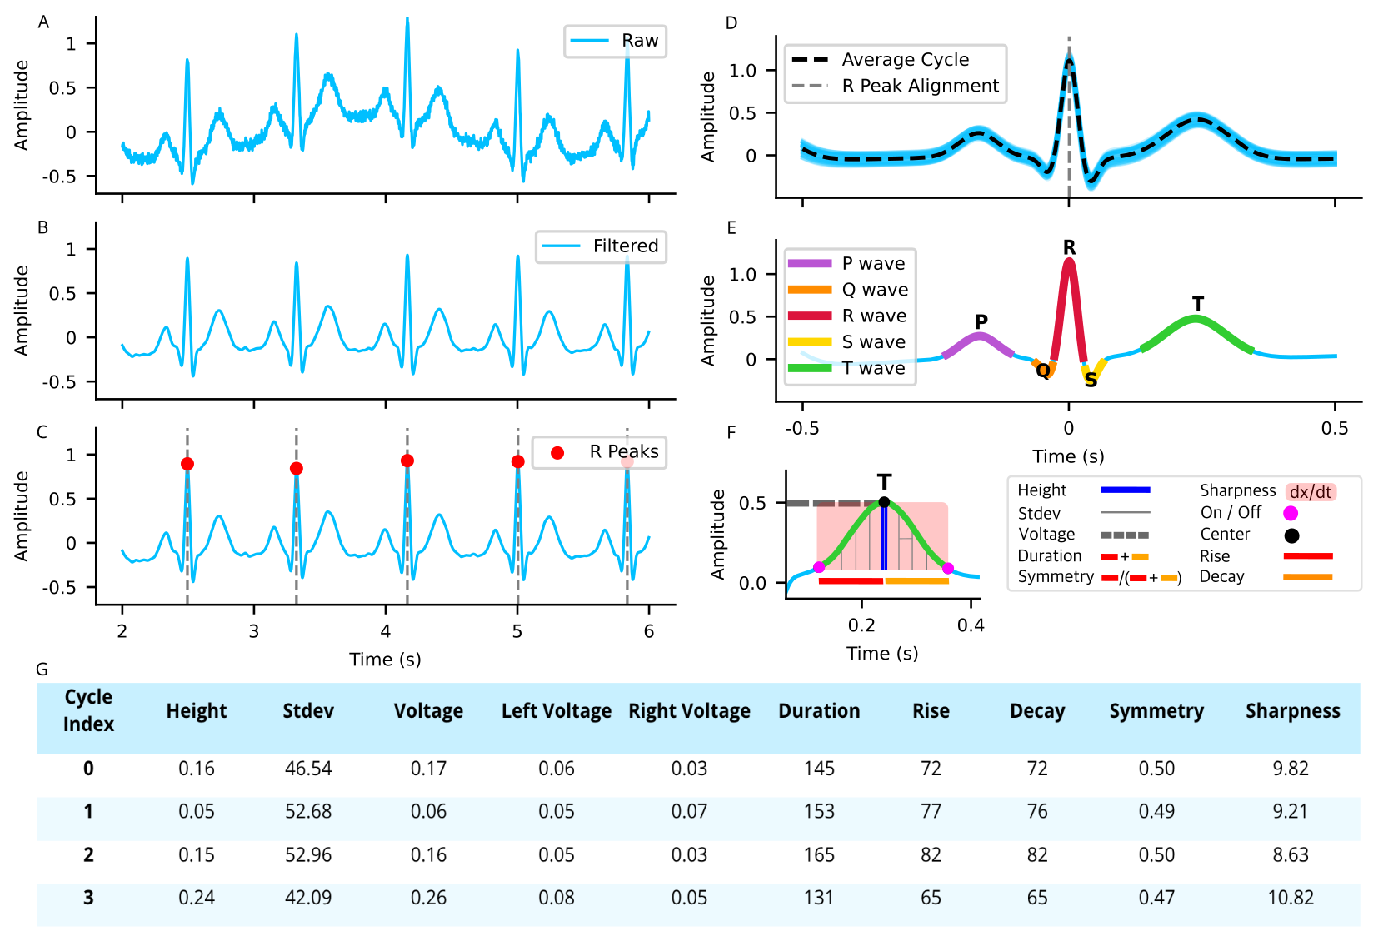
Figure 1. Overview of the PyHEARTS pipeline for physiologically grounded ECG feature extraction.
A. Raw ECG signal from lead II, showing repeated cardiac cycles with visible PQRST morphology. B. Filtered ECG signal after noise reduction to enhance waveform clarity. C. Detected R peaks (red dots), marking the center of each cardiac cycle. D. Averaged ECG waveform aligned to the R peak, shown here only for visualization. The shaded region indicates beat-to-beat variability around the mean cycle. E. Example Gaussian decomposition of a representative beat, illustrating how PyHEARTS parameterizes individual P, Q, R, S, and T components. In practice, this fitting is applied separately to every detected cycle, not to the averaged waveform. F. Schematic of extracted T wave features, including height, standard deviation, voltage, duration, rise time, decay time, symmetry, and sharpness. G. Representative output table of extracted T wave parameters across four cardiac cycles from a single subject.

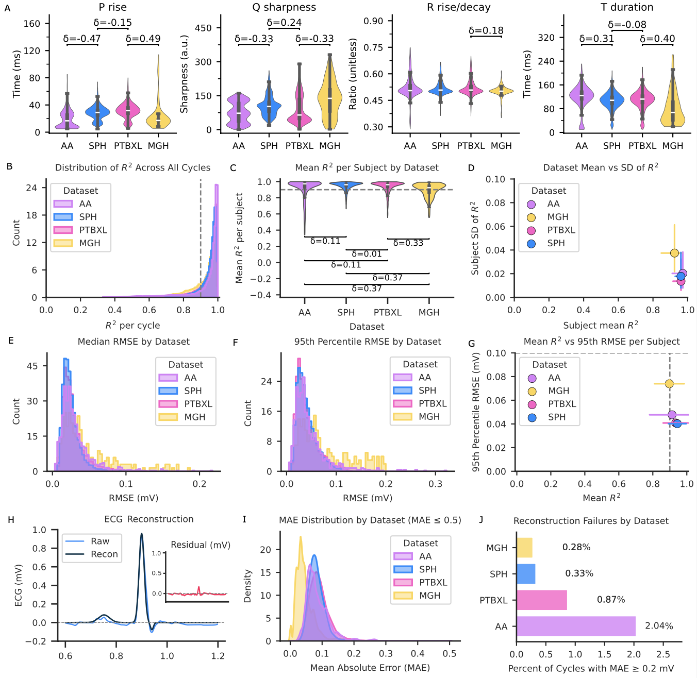
Figure 2. Reconstruction fidelity and error profiles across datasets.
A. Representative waveform feature distributions across datasets (AA, SPH, PTB-XL, MGH). Violin plots show subject-level medians for P rise (ms), Q sharpness (a.u.), R rise/decay ratio (unitless), and T duration (ms). δ values denote median absolute effect sizes. B. Cycle-level R² distribution across all cycles. The dashed line marks the 0.9 fidelity threshold. C. Subject-level mean R² by dataset. Center lines = median; boxes = IQR; whiskers = Tukey 1.5×IQR. Differences were significant (Kruskal–Wallis p < 0.001). D. Relationship between subject mean R² and within-subject SD of R². Points show dataset medians with crosshair IQRs. Variability differed significantly (p < 0.001). E. Distribution of median subject-level RMSE (mV) by dataset. SPH and PTB-XL had lowest errors; MGH highest (p < 0.001). F. Distribution of 95th-percentile RMSE by dataset. Error tails were smallest in PTB-XL and SPH and largest in MGH (p < 0.001). G. Mean R² versus 95th-percentile RMSE per subject. Points show dataset averages (±SD horizontal, ±SEM vertical; SEM bars often smaller than symbols). Dashed lines mark R² = 0.9 and RMSE = 0.1 mV. Fidelity and error were inversely correlated (Spearman ρ = −0.61, p < 0.001). H. Example ECG beat (black) and reconstruction (blue). Inset: residuals (mV) show minimal deviation. I. Distribution of cycle-level mean absolute error (MAE) by dataset for MAE ≤ 0.5 mV. All distributions centered below 0.1 mV with AA showing a broader spread. Nearly all cycles were below 0.2 mV (χ² = 10 932.3, p < 0.001; Cramér’s V = 0.165): AA 98.0%, PTB-XL 99.1%, SPH 99.7%, MGH 99.7%. J. Proportion of cycles exceeding the poor-reconstruction threshold (MAE ≥ 0.2 mV). Failure rates: AA 2.04%, PTB-XL 0.87%, SPH 0.33%, MGH 0.28%. Overall differences were significant (χ² = 10 932.3, p < 0.001; Cramér’s V = 0.165). Final sample sizes: AA (n = 1 010), PTB-XL (n = 4 834), SPH (n = 25 253), MGH (n = 222). Dataset colors: violet = AA, teal = SPH, pink = PTB-XL, yellow = MGH.

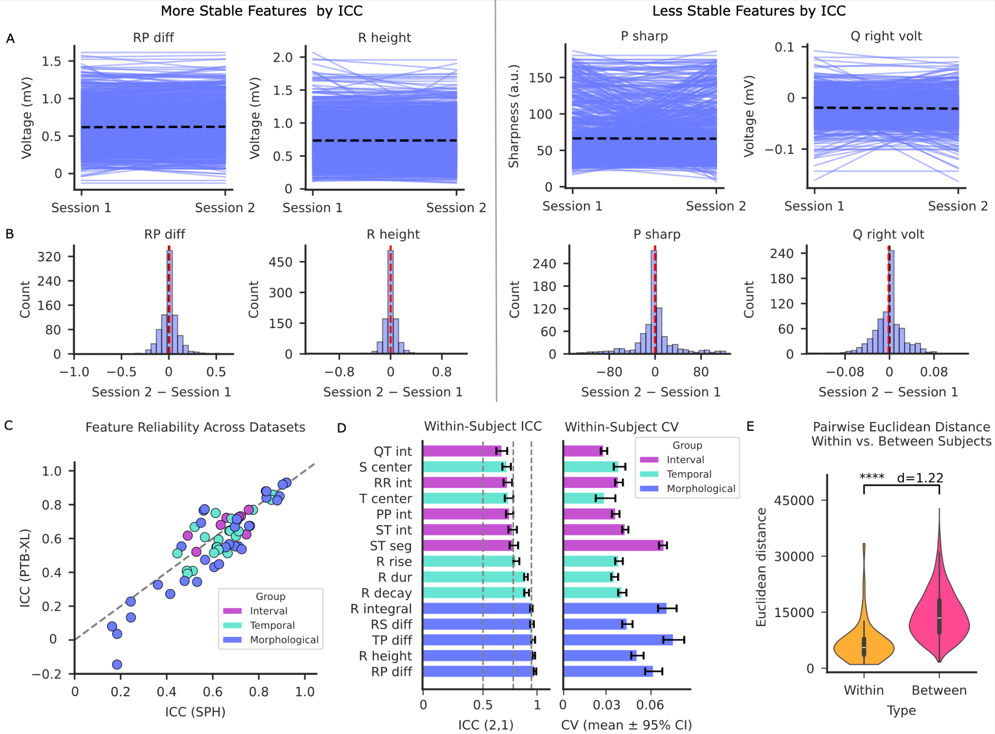
Figure 3. Reliability and variability of ECG features across sessions.
A. Session-to-session trajectories (“spaghetti plots”) for two of the most stable features (RP difference, R height) and two of the least stable features (P sharpness, Q right voltage) in the SPH dataset. Each line represents one participant; dashed lines denote group means. All features exhibited small absolute changes between sessions; “less stable” denotes relative differences in dispersion rather than loss of reproducibility. B. Distributions of session-wise differences (Session 2 – Session 1) for the same features, ordered by Wilcoxon signed-rank p-values. C. Comparison of intraclass correlation coefficients (ICCs) for 62 features across SPH (x-axis) and PTB-XL (y-axis). Each point represents a feature, color-coded by group (interval, temporal, morphological). The diagonal dashed line indicates equivalence. D. The top five most reliable features within each group in the SPH dataset. Left: ICC(2,1) values with 95% confidence intervals; vertical dashed lines mark conventional thresholds for moderate (0.5), good (0.75), and excellent (0.9) reliability. Right: mean coefficients of variation (CV) with 95% confidence intervals. E. Pairwise Euclidean distances between ECG feature vectors from the same subject (within-subject) versus different subjects (between-subject). Distances were significantly smaller within subjects (Wilcoxon rank-sum p < 0.001).

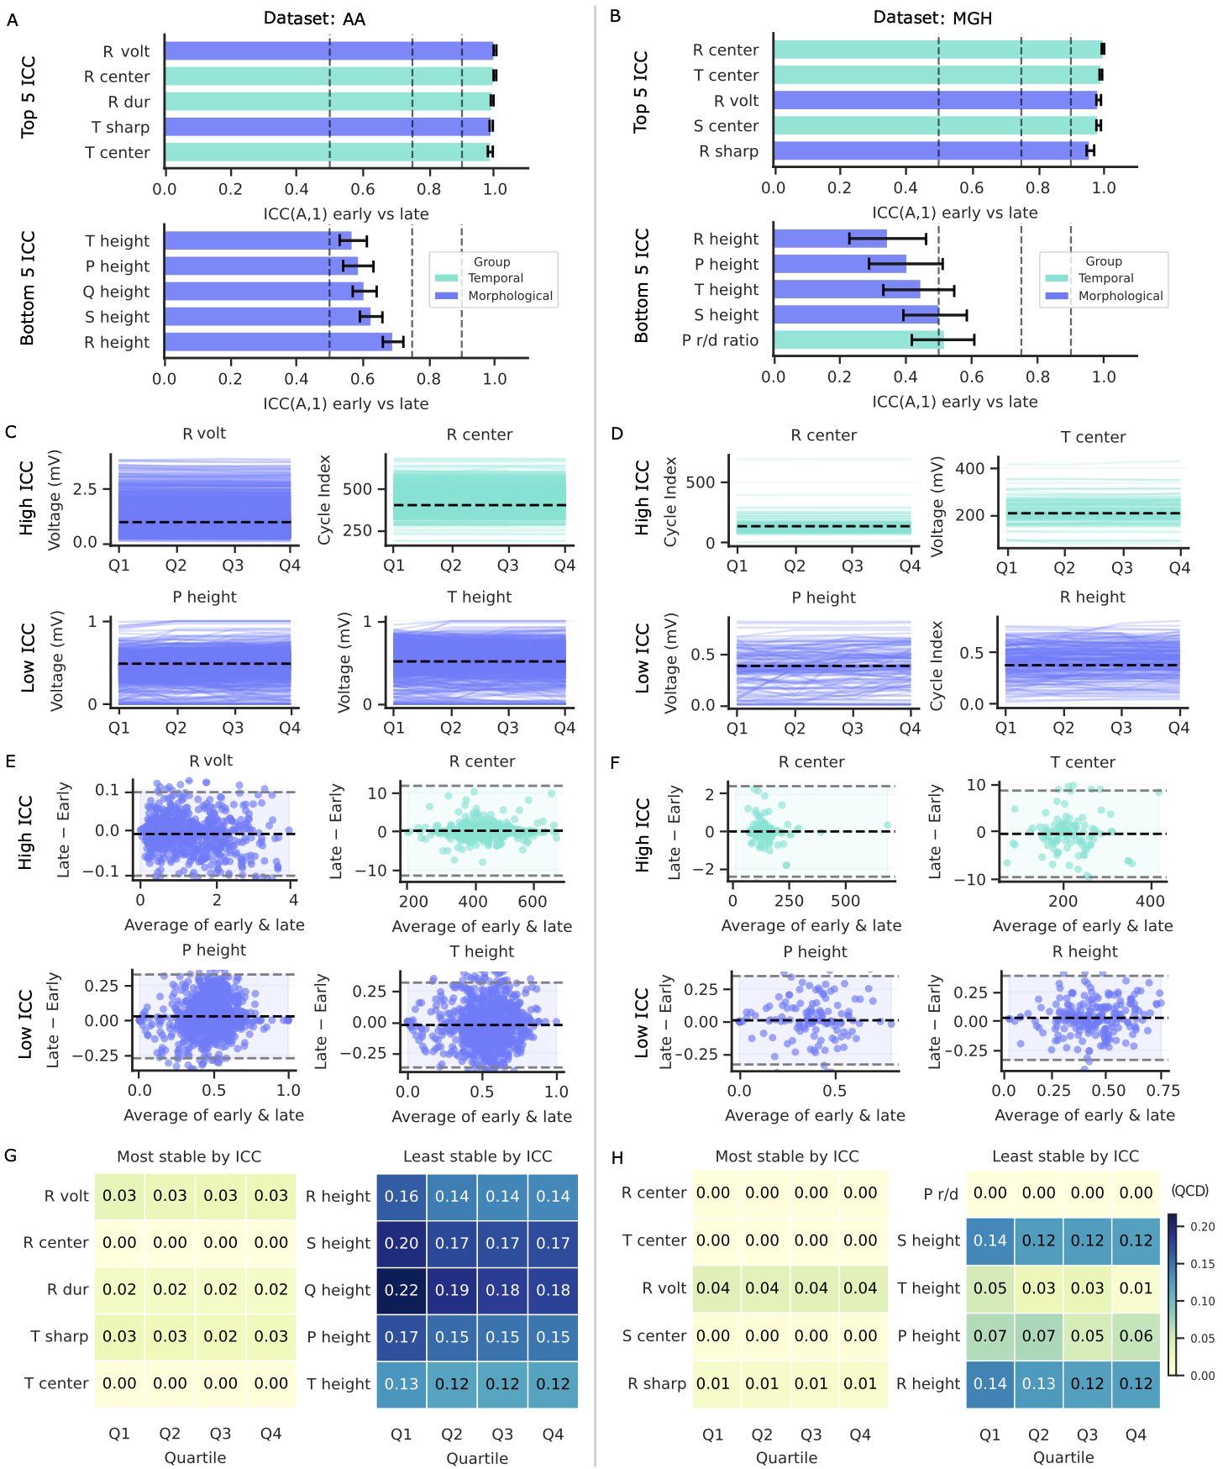
Figure 4. Reliability and variability of ECG features within-session.
A–B. Bar plots of the five highest (top) and five lowest (bottom) features ranked by intraclass correlation coefficient (ICC[A,1], two-way mixed-effects model; error bars = 95% confidence intervals) in the AA dataset (A, n = 1,107) and the MGH dataset (B, n = 228). Features are grouped by type: morphological (purple) and temporal (green). Vertical dashed black lines at ICC = 0.50, 0.75, and 0.90 indicate thresholds for moderate, good, and excellent reliability. C–D. Line plots of beat-level trajectories across quartiles (Q1–Q4) for selected high-ICC and low-ICC features in the AA dataset (C) and the MGH dataset (D). Each line represents one subject; dashed black lines denote subject-level means. Axes show feature value (voltage, cycle index, or ratio as applicable). E–F. Bland–Altman plots showing within-session agreement between early and late recordings for selected features with high and low ICC values in the AA dataset (E) and the MGH dataset (F). Black dashed lines indicate the median difference; grey dashed lines indicate 95% limits of agreement. Features are color-coded by type as in A–B. G–H. Heatmaps of quartile coefficient of dispersion (QCD) values for the same features shown in A–B, stratified by recording quartile (Q1–Q4). Lower QCD values indicate greater within-session stability.

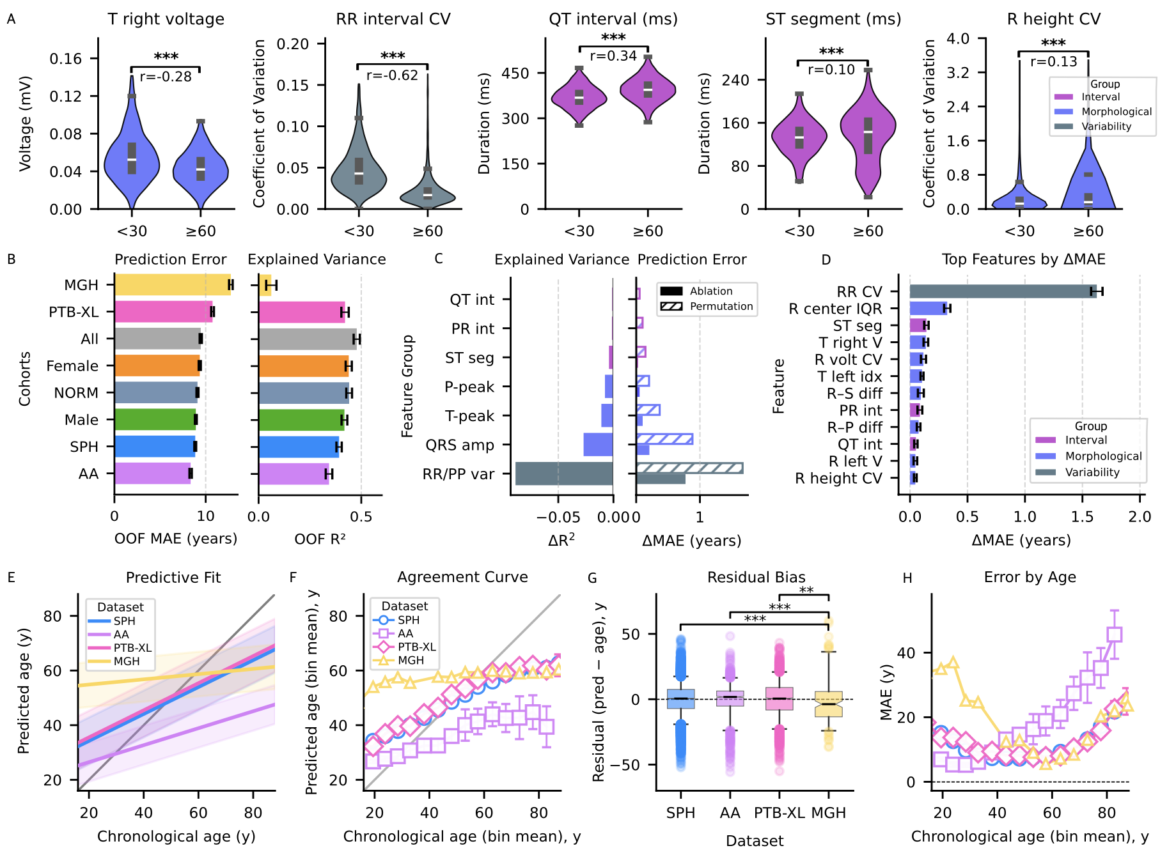

Figure 5. Age prediction and feature contributions using PyHEARTS-derived ECG features.
A. Distribution of five ECG features in young (<30 y) vs. old (≥60 y) healthy subjects (NORM-only); (*** = p<0.001). Colors show super-groups (Morphological = blue, Interval = purple, Variability = gray). B. Bar plots of out-of-fold (OOF) mean absolute error (MAE, left) and coefficient of determination (R², right) across cohorts. C. Bar plots of feature group, ablation (solid) and permutation (hatched), aggregated by ECG component groups: all RR/PP variability parameters; all PR-interval parameters; all QRS-interval parameters; all ST-segment parameters; all QT-interval parameters; all T-wave parameters; all P-wave parameters; all QRS-amplitude parameters (Q, R, S amplitudes, R_minus differences, Gaussian heights). Permutation bars sum ΔMAE across features in a group; ablation bars reflect removal of that group. D. Bar plot of the top individual features ranked by ΔMAE (mean ± s.d.). E. Scatter plot of predicted vs. chronological age with regression fits (colored by dataset) and identity line (gray). F. Agreement curve of predicted vs. chronological age (binned means ± 95% CI) relative to identity, colored by dataset. G. Boxplots of residuals (predicted − chronological age) per cohort, with boxes (IQR), whiskers (5–95%), medians (black), and means (dashed), colored by dataset. Brackets mark significant between-dataset differences (Mann–Whitney U; Benjamini–Hochberg FDR). Stars encode q: * ≤0.05, ** ≤0.01, *** ≤0.001. H. Age-stratified prediction error (MAE, 5-year bins ± 95% CI) by dataset; between-dataset differences assessed with Kruskal–Wallis and FDR-corrected pairwise tests.
Sample sizes: SPH = 25,770 recordings; AA = 1,107 subjects; PTB-XL = 4,967 subjects; MGH = 228 subjects. Young (<30 y) = 314; Old (≥60 y) = 286.

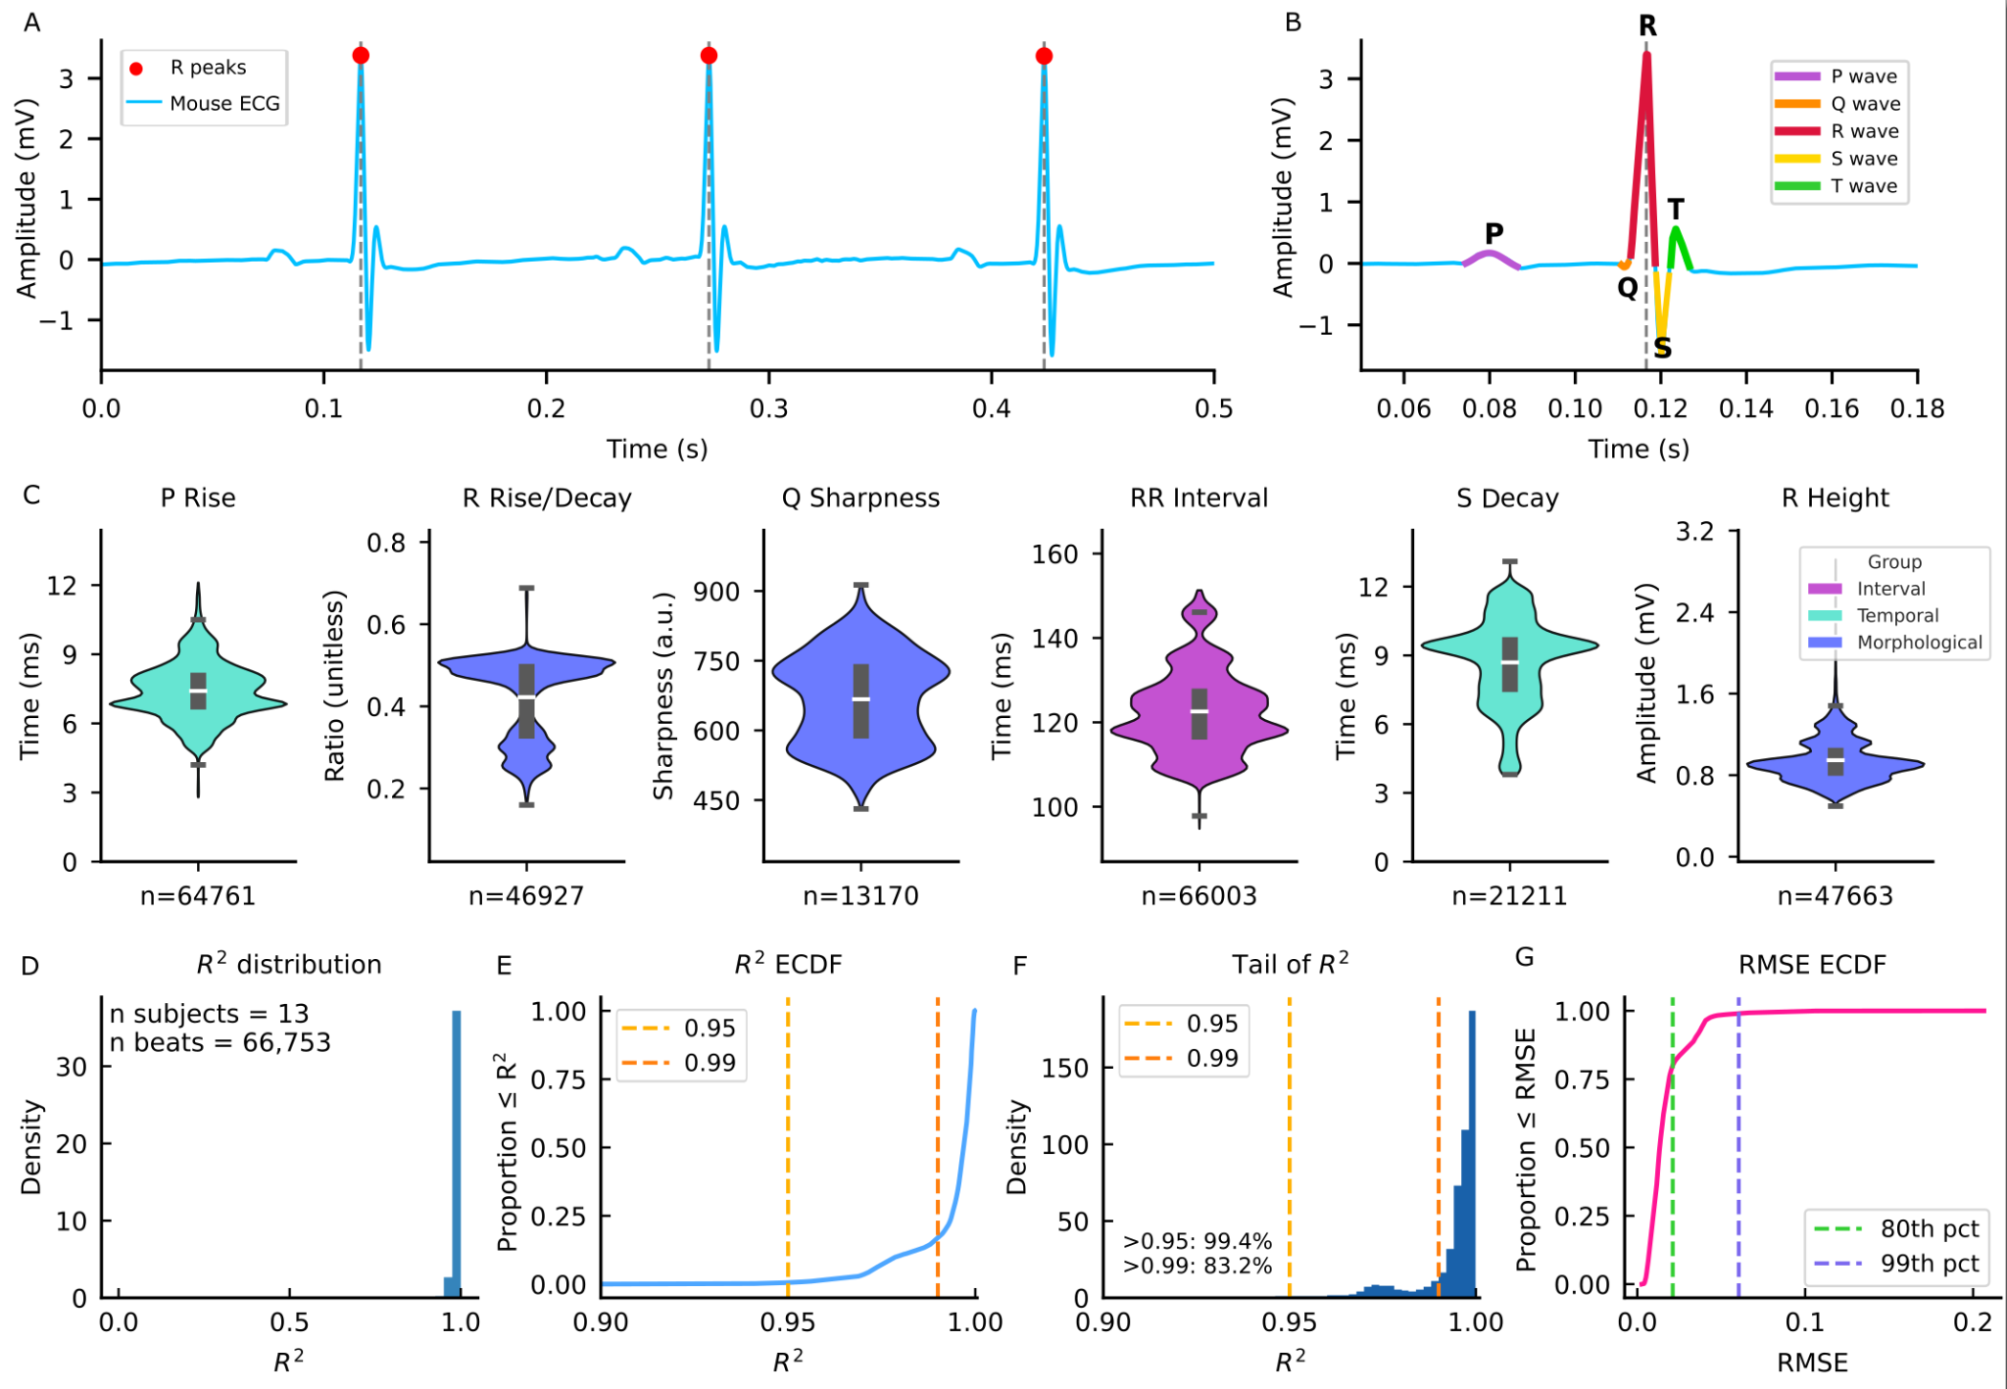

Figure 6. Mouse ECG feature extraction and reconstruction quality using PyHEARTS.
A. Example ECG segment (0–0.5 s) with detected R peaks (red) and reference markers (gray). B. Single cycle (0.05–0.18 s) with labeled Gaussian-fitted P, Q, R, S, and T waves. C. Violin plots of representative features: P rise (n = 64,316), Q sharpness (n = 12,990), R rise–decay ratio (n = 46,280), S duration (n = 19,900), and R decay (n = 46,252); medians shown (black). D. Distribution of cycle-wise reconstruction R² across 66,753 beats from 13 subjects. E. Empirical cumulative distribution of R² with 0.95 and 0.99 thresholds. F. Tail distribution of R² (−log₁₀(1 − R²)). G. Empirical cumulative distribution of RMSE with 80th and 99th percentiles.

Methods

Software Overview
PyHEARTS is a Python toolbox for automated beat-wise analysis of single-lead ECG recordings. An overview of the full processing pipeline is shown in Figure 1. It extracts a comprehensive set of morphological, temporal, and interval-based features from each detected cardiac cycle. These include wave amplitudes and durations, fiducial latencies, conduction intervals (e.g., PR, QRS, QT), and heart rate variability (HRV) metrics (see Supplementary Table 1 for full list).
Each beat is processed independently, and results are output as a structured pandas.DataFrame, with one row per cycle. Sample indices and millisecond-resolved timestamps are recorded for all detected events, enabling traceability between raw signals and derived features. All processed outputs are saved to CSV, alongside a serialized configuration object (ProcessCycleConfig; Supplementary Table 4) that defines all parameters used during analysis. This ensures reproducibility and facilitates reanalysis.
PyHEARTS supports human and mouse ECG recordings with species-specific presets. All parameters, such as detection thresholds, filter settings, and morphological criteria, were defined via the ProcessCycleConfig object. This configuration schema allowed consistent and transparent application of physiological constraints across all ECG records analyzed. Finally, the toolbox requires only standard Python libraries (NumPy, SciPy, pandas) and runs on signals with a minimum of two cardiac cycles with traceable R-peaks.
Parameter Configuration
All thresholds and parameter defaults in ProcessCycleConfig were chosen based on general physiological plausibility. Physiological limits (e.g., RR interval bounds, wave duration minima, polarity expectations) reflect field-established ranges for both human and murine ECGs. Parameters without clear physiological constraints (e.g., peak detection prominence factors, quality thresholds, curve-fitting bounds) were tuned empirically using the AA and PTB-XL datasets to ensure robust behavior across a broad spectrum of signal conditions and demographic diversity. Full configuration defaults are in ProcessCycleConfig, with species-specific presets available via for_human() and for_mouse().

Datasets
We validated PyHEARTS on four human ECG datasets comprising 32,191 recordings from 30,686 subjects, totaling over 2.9 million beats (Table 1). These datasets spanned a wide age range (0 to 100 years), included both healthy and clinical populations, and varied in recording duration, sampling rate, and annotation protocols. All signals were analyzed as single-lead traces, with lead II selected across all datasets. In the rare event that lead II was corrupted or unavailable, lead I was used as a fallback to preserve morphological consistency.
The Autonomic Aging (AA) dataset consisted of resting ECGs sampled at 1,000 Hz from 1,121 healthy adults aged 18 to 85 years (mean age: 32.5). Recordings lasted between 8 and 35 minutes and did not include diagnostic labels.
The Physikalisch Technische Bundesanstalt (PTB-XL) dataset comprised 5,050 ECGs from 4,649 patients, each sampled at 500 Hz and lasting 10 seconds. Note that due to sampling rate requirements (see Sampling Rate section), we were limited to the high-resolution (500 Hz) subset of PTB-XL. Subjects ranged in age from 0 to 95 years (mean: 62.0), and each recording included physician-assigned diagnostic labels.
The Shandong Provincial Hospital (SPH) Clinical Dataset included 25,770 ECGs from 24,666 patients, with a mean age of 50.7 years. Recordings ranged from 10 to 60 seconds in duration and were sampled at 500 Hz. Diagnostic annotations followed standard American Heart Association (AHA) guidelines.
The Massachusetts General Hospital/Marquette Foundation (MGH) Waveform Database contained 250 recordings from 250 individuals aged 1 to 88 years (mean: 58.7), with sampling at 360 Hz. Record durations ranged from 12 to 86 minutes. Clinical labels were available and used where applicable.
Mouse Data
To evaluate cross-species compatibility of the analysis pipeline, baseline ECG recordings were acquired from 13 adult C57BL/6J mice (1.5–6 months old, both sexes) under light isoflurane anesthesia (1.0–1.5% in oxygen)⁵³, in accordance with protocols approved by the Scripps Research IACUC. Signals were recorded using subcutaneous needle electrodes in lead I configuration at a sampling rate of 3,000 Hz (PowerLab, ADInstruments), selected to ensure accurate capture of fast murine cardiac dynamics. No randomization or blinding was performed.
Preprocessing
All ECG signals were preprocessed using a standardized filtering pipeline. A high-pass filter at 0.5 Hz was applied to remove baseline drift, implemented as a 4th-order zero-phase Butterworth filter using forward–backward filtering to preserve phase. Notch filtering was applied at regional mains interference (MGH: 60 Hz; AA, PTB-XL, SPH: 50 Hz).
Sampling Rate
Accurate ECG feature extraction requires sufficient temporal resolution to capture sharp waveform components. Although the Nyquist criterion sets a lower bound of two samples per cycle, reliable detection of deflections like the Q and S waves (lasting as little as 20–40 ms) typically requires at least six samples to preserve waveform morphology and allow precise localization of boundaries. This corresponds to a minimum sampling rate of ~300 Hz. Similar thresholds are supported in signal processing literature⁵⁴, and all human datasets used in this study exceeded this: AA (1,000 Hz), SPH/PTB-XL (500 Hz), and MGH (360 Hz).
In mice, the physiological constraints are more demanding. Murine QRS complexes are typically shorter than 10 milliseconds, with Q and S waves often lasting only 2 to 4 milliseconds. These features contain frequency components in the several-hundred-Hz range. To prevent aliasing and enable reliable sub-millisecond curve fitting, we required a minimum sampling rate of 2,500 Hz for murine ECGs. All mouse recordings used in this study were sampled at or above 3,000 Hz, ensuring fidelity in waveform reconstruction.
Cycle Segmentation
R-peak detection was performed using a two-pass, prominence-based algorithm implemented with scipy.signal.find_peaks.
In the first pass, a permissive refractory period was applied to exclude physiologically implausible peak intervals: 120 milliseconds for the human preset and 67 milliseconds for the mouse preset. These thresholds correspond to theoretical maximum heart rates of approximately 500 beats per minute (bpm) and 900 bpm, respectively^{24,54,55}. This is based on the formula: 60,000 ms/min divided by the RR interval in milliseconds. For example, 60,000 ÷ 120 ms = 500 bpm, and 60,000 ÷ 67 ms ≈ 896 bpm.
The human threshold exceeds typical maximum sinus rates observed during exertion (about 200–220 bpm), allowing a wide margin that helps reject noise while preserving true beats, including rare tachycardic episodes^{56–59}. The mouse threshold accounts for reported peak physiological rates under stress (around 700–800 bpm), with additional headroom for transient extremes^{55,60,61}. These values support the use of a theoretical upper limit for artifact rejection during R-peak detection. Prominence was set adaptively based on the standard deviation of the signal (prominence = 3.0 times the signal’s standard deviation), allowing sensitivity to adjust according to the noise level in each recording^{62,63}.
In the second pass, a refined search was conducted using a dynamic refractory period equal to 55% of the estimated median RR interval, with RR estimates constrained to species-specific physiological ranges (30–240 bpm for humans, 300–1000 bpm for mice)^{55,56,61,62,64–66}. These bounds reflect published limits on sinus rhythm and reduce the risk of artifactual RR values skewing cycle segmentation. Only peaks identified in the second pass were retained for downstream analysis.
Epoching and cycle screening were performed around each detected R peak. A symmetric window was extracted for each beat, with a half-width equal to half the average RR interval for that recording. This ensured full-cycle coverage centered on each R-wave. Each cycle was subjected to two quality checks. First, the beat had to correlate with the global average cycle at ≥0.80. Second, its variance could not exceed five times that of the full trace. Cycles passing both thresholds were retained and indexed for downstream analysis.
Per-cycle baseline and trend removal was then applied. Each beat was corrected in two stages. A baseline offset was removed by subtracting the median voltage of the initial portion of the cycle, defined as the first 200 ms for human signals and 100 ms for murine signals. Then, the linear trend for each cycle was found by fitting a line between the first and last sample of the cycle, and this trend was subtracted. The resulting detrended waveform and slope estimate (cycle_trend) were stored for each beat and served as the foundation for all subsequent steps, including peak localization and morphological fitting.

Peak Detection

PyHEARTS does not assume the presence of all PQRST components in every beat. Unlike classical delineators that estimate fiducial points using fixed windows or global templates, PyHEARTS initializes search regions using physiological priors but adapts them on a per-beat basis using signal-derived features. Candidate P, Q, S, and T waves are evaluated independently using existence, polarity, and amplitude-based validation criteria. If a component cannot be reliably detected within its search window, fails validation, or is physiologically implausible (e.g., absent P wave, low SNR, inverted polarity under the default lead assumption), that component is omitted and its corresponding fiducial and morphology features are recorded as missing (NaN) rather than forced. Gaussian fitting is performed conditionally only for validated components, and failure of one component does not prevent extraction of others within the same beat. Beats with partial component sets are retained for downstream analysis, while analyses requiring a specific component (e.g., PR interval requires P onset) operate only on beats where the required fiducials are present.
Candidate P, Q, R, S, and T waves were identified from detrended ECG waveform using a rule-based approach grounded in signal morphology and timing. For each beat, QRS boundaries were initialized symmetrically around the R peak using a window of ±1.75σ, where σ was computed from the full-width at half-maximum (FWHM) of the R deflection. This base estimate was then dynamically expanded using wavelet-guided offsets.
Discrete wavelet detail coefficients were calculated using a Daubechies-6 (db6) wavelet, with the decomposition level determined by the length of the signal. Peaks in the absolute value of these coefficients that exceeded 1.2 times the signal’s standard deviation were aggregated per beat to form a QRS energy proxy. This threshold (1.2σ) was chosen to balance sensitivity and specificity, based on the expected amplitude distribution of wavelet-transformed ECGs. Prior work in ECG delineation has used similar σ-based thresholds (typically 1.0–1.5σ⁶⁷) to isolate depolarization-related energy while suppressing background noise.
Search windows are initialized using physiological priors but are adjusted on a per-beat basis using signal-derived features, including R-peak width (via FWHM), wavelet energy localization, and recording-specific RR intervals. This allows fiducial localization to adapt to atypical morphologies (e.g., broad QRS, delayed repolarization, variable PR timing) without assuming normal sinus rhythm.
To tailor the analysis to each beat, waveform amplitude strength was quantified and normalized to the 95th percentile of the record. This measure was then linearly mapped to define a beat-specific offset between 1 and 60 milliseconds. The adaptive offset adjusts how far before and after the initial QRS bounds the algorithm searches for the Q and S wave peaks. Beats with larger overall amplitudes receive wider search zones, while lower-amplitude beats receive narrower ones. Although this offset does not represent total QRS duration, it allows the search region to extend beyond 125 milliseconds, consistent with durations observed in healthy rhythms⁶⁸.
The Q wave was defined as the most negative deflection in the interval from the left QRS bound up to, but not including, the R peak. The S wave was defined as the most negative deflection between the R peak and the right QRS bound. If the right bound extended beyond the available signal, it was clamped to 100 samples before the boundary to avoid indexing errors during downstream processing.
P wave detection occurred before the QRS complex, within a window defined by the most positive peak between a start index and the beginning of the QRS. The end of the window was set to the Q wave if present, otherwise to the R peak. The start index was chosen as the earliest of either approximately 10 milliseconds from the start of the cycle. This approach ensured that even in longer pre-QRS intervals, the search window remained bounded and physiologically meaningful.
T wave detection began after a fixed post-QRS guard interval (postQRS_refractory_window_ms), which separated the T-wave search region from residual depolarization in the S-wave tail. This guard reduced false detections near the QRS offset. The interval was set to 10 ms for murine ECGs and 20 ms for human ECGs, reflecting species-specific timing: in mice, T waves typically begin 20–30 ms after the R peak, whereas in humans they appear 40–80 ms after the QRS complex⁶⁸. The T-wave search window extended from the end of this guard interval up to half the detrending window length, ensuring that detection remained within the same cardiac cycle and excluded baseline drift or the onset of the next P wave.
Signal-to-noise ratio (SNR) gating was applied to P and T waves to improve robustness in lower-amplitude regions of the ECG. These waves are more vulnerable to noise from breathing, motion artifacts, and low-frequency drift, and lack the strong polarity and timing cues that define the QRS complex. Q and S waves were not gated, since they could be reliably located based on their expected shape and proximity to the R peak.
For P waves, noise was estimated using a rolling median absolute deviation (MAD), excluding a window equal to the FWHM around the candidate peak. No smoothing was used in P wave detection. For T waves, additional constraints and filtering were required due to their lower amplitude, broader duration, and greater susceptibility to baseline drift compared with depolarization components^{69–71}. The local noise estimate was computed using a fixed exclusion window centered on the candidate (±20 ms for mice, ±10 ms for humans) to avoid contamination from the repolarization slope. This window size reflects the typical width of the T apex region in each species, ensuring noise is sampled from the nearby baseline rather than the repolarization phase itself. When the configuration flag snr_apply_savgol["T"] was enabled, a Savitzky–Golay filter was applied to the detrended signal only for apex smoothing. This step reduced high-frequency fluctuations that otherwise distort the T-peak position in noisy recordings while preserving true morphology. In all cases, amplitude values used for gating and polarity assessment were extracted directly from the unfiltered detrended waveform to maintain physiological fidelity. Candidate P and T waves were retained only if their absolute amplitude exceeded a configurable multiple of the MAD, using the formula: |peak| ≥ k × MAD, where the value of k was set using the snr_mad_multiplier parameter. Typical values were 2.0 for mice and 1.75 to 2.0 for humans. Waves with inverted polarity (negative) in standard ECG leads, such as lead II, were excluded from analysis.
To ensure valid cardiac cycle detection, R-peak detection was constrained by species-specific physiological heart rate ranges. For mice, this range was 300 to 1000 beats per minute (bpm), corresponding to minimum R–R intervals of 67 milliseconds. For humans, the acceptable range was 30 to 240 bpm, with a minimum interval of 120 milliseconds. These bounds helped avoid mislabeling overlapping P, T, or R waves, supported accurate cycle labeling, and ensured valid measurement of durations and wave morphologies.
Candidate P, Q, S, and T peaks were further validated using three criteria: existence, polarity, and R-normalized amplitude. Validation was not applied to R peaks, which served as the cycle reference. First, peaks were excluded if their index was missing or their amplitude was not finite. Second, polarity was checked based on standard lead II morphology: P and T waves were required to be positive, Q and S negative. In other leads with inverted morphology, polarity must be adjusted or the signal inverted upstream, or the candidate will be rejected. For datasets with known inverted polarity, alternate lead placement, or frequent biphasic waves, users can invert the signal or adjust polarity expectations in the configuration; otherwise, components violating polarity constraints are treated as absent and omitted.
Third, peak amplitude was compared to the same-cycle R amplitude, if available and finite. Peaks were retained only if |peak| ≥ α × |R|, where α = amp_min_ratio[component]. These thresholds were drawn from ProcessCycleConfig and matched species-specific presets. For humans, defaults were: P ≥ 0.03, T ≥ 0.05, Q and S ≥ 0.02 × |R|. For mice: P ≥ 0.03, T ≥ 0.04, Q and S ≥ 0.025 × |R|. These values were chosen to sit above the typical noise floor while preserving small physiological deflections. All amplitude comparisons used the detrended, unsmoothed signal, regardless of whether smoothing was used during detection.
Peaks failing any validation step were set to (None, None) and excluded from Gaussian fitting and shape-feature extraction in downstream analysis.
Gaussian Fitting
Gaussian fitting is performed conditionally for each waveform component and only when that component has passed peak detection and validation. Initial fitting was performed without seeding when no valid parameters were available from a previous cycle. For each validated deflection (P, Q, R, S, T), Gaussian parameters were initialized from the detrended ECG signal. The center was set to the detected peak index, the amplitude to the signal value at that index, and the width (σ) was estimated from the full-width at half-maximum (FWHM) using the standard conversion: σ = FWHM / 2.3548. A minimum σ of 0.5 samples was enforced to avoid instability in narrow or low-amplitude peaks.
Waveforms were fitted using nonlinear least-squares optimization (scipy.optimize.curve_fit) with the trust-region reflective algorithm. Bounds were defined as ±20% around the initial estimates of center, amplitude, and σ (bound_factor = 0.20). Amplitude bounds were centered on the signed initial guess, which preserves waveform polarity and ensures that negative waves (e.g., Q and S) remain negative during optimization. The solver was allowed up to 2,500 function evaluations per fit.
If a valid Gaussian fit existed for a component in the previous cycle, its center, amplitude, and σ were used as the initial guess. Bounds were recomputed using the same ±20% factor, and all guesses were clamped within those limits. If the seeded fit succeeded, its parameters were used for the next beat; otherwise, the algorithm fell back to the unseeded path.
After fitting, the Gaussian center was refined by snapping to the nearest local extremum in the detrended signal. This step ensured that the reported peak corresponded to the true voltage apex of the measured waveform, rather than the theoretical maximum of the fitted curve. Because Gaussian fits can slightly misalign with the actual peak, especially in asymmetric or noisy waves, the snapping correction anchors the model to the empirical signal. The snapping window was ±(half-FWHM) for seeded fits, based on the fitted σ, or a fixed ±10-sample window for unseeded fits. Final gaussian parameters (center, amplitude, σ, and computed FWHM = $\sqrt{(2ln(2))σ}$ were stored in both sample and millisecond units, along with global indices for traceability.
Feature Extraction
Morphological features were extracted from the Gaussian-reconstructed ECG signal, defined as the sum of all fitted components. This approach was chosen over using the raw ECG to ensure smooth, noise-robust wave delineation.
For each detected wave (P, Q, R, S, T), onset and offset were defined as the points where the fitted signal fell below 30% of the wave’s peak amplitude. This fixed threshold (threshold_fraction = 0.30) was applied with polarity-aware logic: upward crossings for positive deflections (P, R, T) and downward crossings for negative deflections (Q, S). The 30% level was chosen to preserve small but physiologically relevant features such as Q and S waves while avoiding premature truncation at the baseline.
The search for these threshold crossings proceeded outward from the Gaussian peak center, but the maximum search distance was limited in two steps. First, the half-window was scaled to the fitted width of the component, set to twice its standard deviation (shape_search_scale = 2.0). This allowed the window to adapt to broad versus narrow waveforms. Second, this dynamic window was capped by fixed physiologic limits defined separately for each wave type and species (e.g., human T ≤200 ms, mouse T ≤60 ms). This combination ensured that the search was wide enough to capture physiologic morphology but bounded to avoid encroaching into neighboring deflections or noise.
For human data, the P wave window was capped at 160 ms (typical duration 80–110 ms), ≤60 ms for Q and S, ≤80 ms for R (total QRS expected duration 70–110 ms), and the T wave at 200 ms (expected 150–250 ms). For mouse data, reflecting shorter cardiac cycles at 600–800 bpm, the P wave was capped at 35 ms (expected 5–15 ms), the Q and S at ≤12 ms, ≤18 ms for R (expected QRS total 10–20 ms), and the T wave at 60 ms (expected 40–80 ms). This two-tiered policy allowed the delineation window to adapt to the empirical shape of each wave while remaining within physiologically plausible boundaries.
For each component, several morphological features were computed from the fitted signal between the detected onset and offset. These included total duration, rise and decay times (onset to peak and peak to offset, respectively), and rise–decay symmetry, defined as the ratio of rise time to total duration. Sharpness was quantified as the 95th percentile of the first derivative within the wave boundaries, normalized by amplitude; the normalization mode (“peak-to-peak”) used the voltage difference between the component’s maximum and minimum as the scaling factor. This approach provides a consistent, polarity-independent measure of sharpness that accounts for both positive and negative deflections. The voltage integral was computed using trapezoidal integration of the detrended fitted signal within the wave bounds, yielding a measure in microvolt-milliseconds (µV·ms).
Cardiac conduction intervals were derived directly from the onset and offset times of the relevant fitted waves. These included PR, QRS, and QT intervals, along with beat-wise metrics such as peak amplitudes, Gaussian fit parameters, and interdeflection voltage differences. Taken together, these steps defined a reproducible and physiologically grounded pipeline for waveform delineation and feature extraction. A complete list of computed features is provided in Supplementary Table 1.
Fit metrics
Each Gaussian fit was evaluated using two reconstruction metrics: the squared Pearson correlation coefficient (R²) and the root mean squared error (RMSE), both computed between the detrended ECG signal and the fitted waveform. These metrics quantified how well the Gaussian model approximated the true signal morphology.
A beat was considered successfully parameterized if at least one major component was successfully detected and fit; missing or failed components were handled independently and recorded as missing values, allowing beats with absent P waves or poorly defined T waves to contribute valid QRS- and RR-derived features. . Components that failed were excluded independently, and their associated features were marked as missing. Partial success was permitted, allowing valid components from a given cycle to contribute to downstream analysis even when others failed.
RR and PP intervals were smoothed using a 3-beat moving average and filtered to retain only values within species-specific bounds, as defined in the configuration. This limited smoothing was applied only to RR and PP because these intervals exhibit high beat-to-beat variability due to physiological rhythm fluctuations and detection jitter, both of which can introduce spurious local outliers. Smoothing stabilizes instantaneous rate estimates without distorting true timing trends. In contrast, other interval features (e.g., PR, QT, QRS) describe intra-beat morphology rather than inter-beat timing and are less affected by cycle-to-cycle variability or detector noise; thus, they were left unsmoothed to preserve each beat’s exact waveform geometry. All time-based thresholds and durations were converted to samples using round(ms · fs / 1000), and all processing was governed by a centralized configuration object for reproducibility.
Heart rate variability
Heart rate variability (HRV) features were computed from RR intervals using standard time-domain measures: mean heart rate, SDNN, RMSSD, and NN50. These metrics were calculated only when at least 60 valid RR intervals were available. If the threshold was not met, HRV outputs were excluded.
Cardiac cycles were excluded from analysis under the following conditions: missing input data, failure to fit key waveform components, or presence of NaNs in required fields. In cases of partial failure, only the affected features were marked as missing, while valid outputs from the same cycle were retained.
----

Statistical Analysis
All computations were performed in Python using NumPy, SciPy, statsmodels, Pandas and custom modules within the PyHEARTS toolbox. Visualization of results was carried out using matplotlib and seaborn.
Data Cleaning
All raw feature tables were processed using a standardized data cleaning pipeline to ensure physiological plausibility and statistical robustness. For each input file, CSVs were read into memory and underwent the following preprocessing steps: (1) Polarity constraints were applied to enforce electrophysiological validity. P, R, and T waves were required to have positive center voltages, while Q and S waves were expected to be negative. Values that violated these sign rules or showed incorrect peak polarity based on Gaussian fits were replaced with missing values (NaN). (2) Outlier removal was performed on all numeric columns with at least 10 valid entries. Values more than three standard deviations from the column mean were marked as NaN. (3) Identifier formatting ensured that the ecg_id and cycle_index fields were stored as nullable integers, preserving missing values while maintaining consistency across files. Cleaned files were saved and used in all downstream analyses. Importantly, these plausibility filters do not impute missing components; they only mark implausible component-specific values as missing while retaining other valid features from the same beat.
Feature Engineering
To quantify variability in cardiac morphology and timing within each subject, three statistical measures were computed per feature: standard deviation, coefficient of variation, and interquartile range. The standard deviation provided an absolute measure of dispersion across cardiac cycles. The coefficient of variation, defined as the standard deviation divided by the absolute mean, captured relative variability and was suppressed when the mean value fell below machine precision to prevent unstable estimates. The interquartile range, calculated as the difference between the 75th and 25th percentiles, served as a robust non-parametric indicator of spread. Each variability metric was computed independently per feature and appended to the feature table using suffixes indicating the corresponding measure (e.g., _std, _cv, _iqr).
Subject-level features and variability metrics were compiled into a unified table for downstream statistical analysis.
Dataset Comparisons
To compare feature distributions across datasets, we used the Kruskal–Wallis test as a non-parametric omnibus comparison. Effect sizes were reported as η², computed using the formula η² = (H − k + 1)/(n − k), where H is the Kruskal–Wallis test statistic, k is the number of groups, and n is the total number of observations. Pairwise differences were assessed using two-sided Wilcoxon rank-sum (Mann–Whitney U) tests with asymptotic p-values and tie correction. Multiple comparisons were controlled using the Benjamini–Hochberg false discovery rate procedure⁷² at q < 0.05, applied independently within each feature group.
For each pairwise comparison, we reported Cliff’s δ along with 95% confidence intervals derived from 2,000 percentile bootstrap resamples. Median differences between groups were also computed with bootstrap confidence intervals using the same resampling framework. To maintain computational efficiency, large cohorts (n > 10,000) were randomly downsampled once prior to resampling.
Reconstruction quality was evaluated at the cycle level using three metrics: R², RMSE, and MAE, calculated within a 600 ms window centered on each R peak, independent of species. The 600 ms threshold was chosen to capture the full morphology of a typical cardiac cycle segment (P wave, QRS complex, and T wave) while avoiding overlap with adjacent beats. Subject-level summaries were computed as the median of cycle-level values, along with the mean and standard deviation of R², the median and 95th percentile of RMSE, and the median of MAE. Thresholds for high-quality reconstructions were defined as R² ≥ 0.9, RMSE ≤ 0.1 mV, and MAE ≤ 0.2 mV^{47–49}. A quadrant-based classification was used to determine the proportion of subjects meeting both fidelity and error criteria.
To compare reconstruction performance across datasets, we used chi-squared tests of independence. Effect sizes for categorical outcomes were reported using Cramér’s V or Cohen’s h, depending on the number of groups being compared. Associations between reconstruction fidelity metrics (e.g., mean R² vs. 95th percentile RMSE) were quantified using Spearman’s rank correlation (ρ). All statistical tests were two-sided and non-parametric unless otherwise specified.

Reliability and Predictive Modeling
Between Session
We evaluated between-session reliability of ECG features using PTB-XL and SPH. The PTB-XL subset included 294 subjects with at least two valid 500 Hz lead II recordings (588 total ECGs). From SPH, 1,048 subjects had at least two lead II recordings (2,096 total ECGs). For consistency, the first two recordings per subject (lowest ECG identifiers) were selected, and only subjects with complete data from both sessions were retained.
Beat-wise features were extracted using the PyHEARTS pipeline and summarized at the session level by taking the median across beats. Features were grouped into morphological (e.g., voltages, waveform integrals, sharpness), temporal (e.g., durations, rise and decay times, Gaussian centers), and interval-based measures (e.g., PR, QT, RR, PP). Grouping was performed using predefined keyword-based rules applied uniformly across datasets.
Reliability was quantified with intraclass correlation coefficients (ICCs) estimated for each feature using a two-way mixed-effects, absolute-agreement model [ICC(A,1)], implemented in the pingouin package. Confidence intervals were obtained using Fisher’s z-transformation. Within each dataset, features were ranked by ICC to identify the most and least stable measures. To evaluate generalizability, ICC rankings from PTB-XL and SPH were compared directly, allowing identification of features that consistently demonstrated high or low reliability across both cohorts. The top- and bottom-ranked features were selected for visualization to illustrate the spectrum of between-session stability.
Within Session
To evaluate within-recording stability, we compared feature values between early and late time windows within each ECG recording. A dataset-specific "late" beat index was defined as the largest cycle index present in at least 80% of recordings (AA: 835; MGH: 3,862). The early window consisted of beats 1–10, and the late window included the final 10 beats ending at the dataset-specific late index. Subjects were retained if both windows contained at least six valid beats. For each feature, we computed the average within each window.
To assess change over time, we tested whether the feature values differed between early and late windows using the paired t-test if both distributions passed the D’Agostino test for normality. Otherwise, we used the Wilcoxon signed-rank test. We summarized differences as the mean (for t-tests) or median (for Wilcoxon) of the within-subject late-minus-early values. To correct for multiple comparisons across features, we applied the Benjamini–Hochberg procedure to control the false discovery rate (FDR), reporting adjusted q-values.
To estimate the within-session test–retest reliability, we computed intraclass correlation coefficients (ICC[A,1]) for each ECG feature. This model reflects absolute agreement in a two-way mixed-effects design with a single measurement per phase. Each recording was divided into early and late phases, defined as the first and last deciles of valid beats based on subject-specific beat count. Subjects were included if both phases contained at least six valid beats. No imputation was used; missing beats were excluded listwise within each phase. For each subject and feature, we computed the median value within the early and late phases. ICCs were estimated using pingouin.icc (v0.5.3), specifying a two-way mixed-effects, absolute-agreement model (type = "ICC2", unit = "single"). Confidence intervals were computed using Fisher z-transformation, as implemented by the package. We report ICCs, 95% confidence intervals, and the number of subjects contributing to each feature. Axis clipping in visualizations (e.g., bar plots) did not affect ICC computation.
To assess temporal variability across full recordings, we computed quartile coefficients of dispersion (QCD) for each ECG feature. Beats within each subject were first ranked by normalized index r = (rank − 1) / (B − 1), where B is the total number of valid beats. Quartile bins were defined as Q1: [0, 0.25], Q2: (0.25, 0.5], Q3: (0.5, 0.75], Q4: (0.75, 1], using pandas.cut(...,right=True,include_lowest=True). Subject–quartile combinations with fewer than two beats were excluded. Subjects with fewer than four total beats were excluded entirely from the analysis. For each subject and feature, QCD was computed separately in each quartile as: QCD = (Q3 − Q1) / (Q3 + Q1), where Q1 and Q3 are the first and third quartiles of the beat-level values within that quartile. If Q3 + Q1 = 0, QCD was set to NaN. Feature-level QCD profiles were then aggregated across subjects by the median, producing a four-column QCD profile (Q1–Q4) per feature. This approach complements the early–late analysis by capturing temporal fluctuations across the entire session rather than only at the endpoints. Using normalized quartiles allows comparisons across subjects with different recording lengths. QCD was chosen over the coefficient of variation for its scale invariance and robustness to non-normal distributions.
For visualization, features were ranked by ICC(A,1), and QCD heatmaps were plotted for the top five and bottom five features across both datasets. Color limits were fixed based on the global finite minimum and maximum across AA and MGH to enable direct cross-dataset comparison.
Aging
To examine the relationship between ECG features and age, we first performed two-sided Mann–Whitney U tests comparing adults under 30 years and those aged 60 and older. Features with significant group differences in morphology, timing, or variability were retained for predictive modeling.
Chronological age was modeled using histogram-based gradient boosting regressors (HistGradientBoostingRegressor, scikit-learn). A five-fold GroupKFold cross-validation was used to avoid subject leakage. Within each fold, features were z-scored based on training data, and low-variance (≤1e–6) or near-duplicate (|r| > 0.999) features were removed. Standardization and pruning were applied only to training folds to prevent data leakage.
After model training, predictions were calibrated using isotonic regression. Performance was evaluated using out-of-fold (OOF) R² and mean absolute error (MAE) in years. Subgroup performance was reported by sex and dataset. Linear regression baselines, including ordinary least squares and Ridge regression with tuned α, were fit using the same pipeline for comparison.
Feature importance was estimated using OOF permutation analysis, where the impact of each feature was quantified by its effect on MAE. Grouped ablation tests were used to assess the contribution of different physiological feature sets (e.g., removing variability features). The resulting change in MAE (ΔMAE) was used to quantify each group’s predictive value.
To assess age-prediction accuracy across the lifespan, we computed the mean absolute error (MAE) between predicted and chronological age within fixed-width age bins (5 years). MAEs were averaged within bins for each dataset, with 95% confidence intervals estimated via the Student’s t-distribution. To formally test for between-dataset differences in error, we applied Kruskal–Wallis tests within each age bin, followed by pairwise Mann–Whitney U tests. Multiple comparisons across bins and dataset pairs were controlled using the Benjamini–Hochberg false discovery rate (FDR), and we report FDR-adjusted q-values alongside raw p-values (Supplementary Table 3).

Cross-Species Validation
To evaluate the generalizability of the PyHEARTS pipeline across species, we applied the same waveform modeling and feature extraction procedures to murine ECG recordings. These signals were obtained under light anesthesia from prior studies⁵³, and were sampled at 3,000 Hz or higher to ensure adequate resolution of rapid deflections. This met the minimum requirement of 2,500 Hz for mouse ECG processing established by PyHEARTS.
Species-specific configuration settings were used to adapt to murine physiology, including narrower QRS complexes, higher heart rates, and lower-amplitude Q and S deflections. Aside from these parameter changes, the segmentation, detrending, Gaussian fitting, feature extraction, and quality control steps remained identical to those used for human data.
Beat-wise reconstructions and morphological features were successfully generated from mouse ECGs using the same unified processing framework. This cross-species application demonstrated that PyHEARTS can extract interpretable, physiologically relevant cardiac features from both human and mouse ECGs with minimal modification, supporting its use in translational research.

References

1. Reardon, M. & Malik, M. Changes in Heart Rate Variability with Age. Pacing Clin. Electrophysiol. 19, 1863–1866 (1996).
2. Almeida-Santos, M. A. et al. Aging, heart rate variability and patterns of autonomic regulation of the heart. Arch. Gerontol. Geriatr. 63, 1–8 (2016).
3. Thayer, J. F., Yamamoto, S. S. & Brosschot, J. F. The relationship of autonomic imbalance, heart rate variability and cardiovascular disease risk factors. Int. J. Cardiol. 141, 122–131 (2010).
4. CARNEY, R. M. & FREEDLAND, K. E. Depression and heart rate variability in patients with coronary heart disease. Cleve. Clin. J. Med. 76, S13–S17 (2009).
5. Stein, P. K. & Reddy, A. Non-Linear Heart Rate Variability and Risk Stratification in Cardiovascular Disease. Indian Pacing Electrophysiol. J. 5, 210–220 (2005).
6. Arakaki, X. et al. The connection between heart rate variability (HRV), neurological health, and cognition: A literature review. Front. Neurosci. 17, (2023).
7. Vrinceanu, T. et al. Mind the Rhythm: ECG QT Dispersion and Cognition in Healthy Older Adults. Front. Psychol. 11, (2020).
8. Imahori, Y., Vetrano, D. L., Ljungman, P. & Qiu, C. Electrocardiographic Predictors of Cognitive Decline and Dementia: A Systematic Review. J. Alzheimer’s Dis. 84, 1303–1322 (2021).
9. Weil, E. L. et al. Artificial Intelligence–Enabled Electrocardiogram for Atrial Fibrillation Identifies Cognitive Decline Risk and Cerebral Infarcts. Mayo Clin. Proc. 97, 871–880 (2022).
10. Tasci, B., Tasci, G., Dogan, S. & Tuncer, T. A novel ternary pattern-based automatic psychiatric disorders classification using ECG signals. Cogn. Neurodyn. 18, 95–108 (2024).
11. Berling, I. et al. A review of ECG and QT interval measurement use in a public psychiatric inpatient setting. Australas. Psychiatry 26, 50–55 (2018).
12. Sevcencu, C. & Struijk, J. J. Autonomic alterations and cardiac changes in epilepsy. Epilepsia 51, 725–737 (2010).
13. Shmuely, S., van der Lende, M., Lamberts, R. J., Sander, J. W. & Thijs, R. D. The heart of epilepsy: Current views and future concepts. Seizure 44, 176–183 (2017).
14. Greene, K. R. 8 The ECG waveform. Baillières Clin. Obstet. Gynaecol. 1, 131–155 (1987).
15. Institute of Biomedical Problems of the Russian Academy of Sciences, Baevsky, R. М. & Chernikova, A. G. Heart rate variability analysis: physiological foundations and main methods. Cardiometry 66–76 (2017) doi:10.12710/cardiometry.2017.10.6676.
16. Davies, A. & Scott, A. ECG Interpretation. in Starting to Read ECGs: A Comprehensive Guide to Theory and Practice (eds. Davies, A. & Scott, A.) 17–43 (Springer, London, 2015). doi:10.1007/978-1-4471-4965-1_2.
17. Hussein, O. et al. Improving automated labeling with deep learning and signal segmentation for accurate ECG signal analysis. Serv. Oriented Comput. Appl. 19, 93–106 (2025).
18. Peimankar, A. & Puthusserypady, S. DENS-ECG: A deep learning approach for ECG signal delineation. Expert Syst. Appl. 165, 113911 (2021).
19. Tutuko, B. et al. Short Single-Lead ECG Signal Delineation-Based Deep Learning: Implementation in Automatic Atrial Fibrillation Identification. Sensors 22, 2329 (2022).
20. Sri, G. B. et al. Automated Detection of Heart Abnormalities Through ECG Processing using NI LabVIEW. in 2025 3rd International Conference on Self Sustainable Artificial Intelligence Systems (ICSSAS) 76–81 (2025). doi:10.1109/ICSSAS66150.2025.11080700.
21. Saha Tchinda, B., Tchiotsop, D. & Tchinda, R. Classification of cardiac arrhythmias using ECG shape-adapted wavelets and BiLSTM network. Measurement 257, 118832 (2026).
22. Shoughi, A., Dowlatshahi, M. B., Amiri, A., Kuchaki Rafsanjani, M. & Batth, R. S. Automatic ECG classification using discrete wavelet transform and one-dimensional convolutional neural network. Computing 106, 1227–1248 (2024).
23. Pilia, N. et al. ECGdeli - An open source ECG delineation toolbox for MATLAB. SoftwareX 13, 100639 (2021).
24. Goldberger, A. L. et al. PhysioBank, PhysioToolkit, and PhysioNet. Circulation 101, e215–e220 (2000).
25. Lopez-Jimenez, F. et al. Assessing Biological Age: The Potential of ECG Evaluation Using Artificial Intelligence: JACC Family Series. JACC Clin. Electrophysiol. 10, 775–789 (2024).
26. Attia, Z. I. et al. Age and Sex Estimation Using Artificial Intelligence From Standard 12-Lead ECGs. Circ. Arrhythm. Electrophysiol. 12, e007284 (2019).
27. Ribeiro, A. H. et al. Automatic diagnosis of the 12-lead ECG using a deep neural network. Nat. Commun. 11, 1760 (2020).
28. Hannun, A. Y. et al. Cardiologist-level arrhythmia detection and classification in ambulatory electrocardiograms using a deep neural network. Nat. Med. 25, 65–69 (2019).
29. Johnson, L. S. et al. Artificial intelligence for direct-to-physician reporting of ambulatory electrocardiography. Nat. Med. 31, 925–931 (2025).
30. Asif, M. S. et al. Hybrid Deep Learning and Discrete Wavelet Transform-Based ECG Biometric Recognition for Arrhythmic Patients and Healthy Controls. Sensors 23, 4635 (2023).
31. Kahil, M. S., Maalem, S., Sahraoui, A., Derdour, M. & Deriche, M. An explainable hybrid deep learning model for ECG classification of cardiac conditions. Biomed. Signal Process. Control 113, 108906 (2026).
32. Holgado-Cuadrado, R., Plaza-Seco, C., Lovisolo, L. & Blanco-Velasco, M. A Deep and Interpretable Learning Approach for Long-Term ECG Clinical Noise Classification. IEEE Trans. Biomed. Eng. 72, 425–434 (2025).
33. Goettling, M., Hammer, A., Malberg, H. & Schmidt, M. xECGArch: a trustworthy deep learning architecture for interpretable ECG analysis considering short-term and long-term features. Sci. Rep. 14, 13122 (2024).
34. Riek, N. T. et al. ECG-SMART-NET: A Deep Learning Architecture for Precise ECG Diagnosis of Occlusion Myocardial Infarction. Preprint at https://doi.org/10.48550/arXiv.2405.09567 (2024).
35. Burke, G. M., Wang, N., Blease, S., Levy, D. & Magnani, J. W. Assessment of reproducibility – automated and digital caliper ECG measurement in the Framingham Heart Study. J. Electrocardiol. 47, 288–293 (2014).
36. Kashou, A. H., May, A. M. & Noseworthy, P. A. Artificial Intelligence-Enabled ECG: a Modern Lens on an Old Technology. Curr. Cardiol. Rep. 22, 57 (2020).
37. Xie, Y. et al. Theta Oscillations and Source Connectivity During Complex Audiovisual Object Encoding in Working Memory. Front. Hum. Neurosci. 15, 614950 (2021).
38. Pham, H., Egorov, K., Kazakov, A. & Budennyy, S. Machine learning-based detection of cardiovascular disease using ECG signals: performance vs. complexity. Front. Cardiovasc. Med. 10, (2023).
39. Ansari, M. Y. et al. Estimating age and gender from electrocardiogram signals: A comprehensive review of the past decade. Artif. Intell. Med. 146, 102690 (2023).
40. Cole, S. & Voytek, B. Cycle-by-cycle analysis of neural oscillations. J. Neurophysiol. 122, 849–861 (2019).
41. Jackson, N., Cole, S. R., Voytek, B. & Swann, N. C. Characteristics of Waveform Shape in Parkinson’s Disease Detected with Scalp Electroencephalography. eNeuro 6, ENEURO.0151-19.2019 (2019).
42. Vinding, M. C. et al. Oscillatory and non-oscillatory features of the magnetoencephalic sensorimotor rhythm in Parkinson’s disease. Npj Park. Dis. 10, 51 (2024).
43. Schumann, A. & Bär, K. Autonomic Aging: A dataset to quantify changes of cardiovascular autonomic function during healthy aging. [object Object] https://doi.org/10.13026/2HSY-T491.
44. Wagner, P. et al. PTB-XL, a large publicly available electrocardiography dataset. Sci. Data 7, 154 (2020).
45. Liu, H. et al. A large-scale multi-label 12-lead electrocardiogram database with standardized diagnostic statements. Sci. Data 9, (2022).
46. Welch JP, Ford PJ, Teplick RS, Rubsamen RM. The Massachusetts General Hospital-Marquette Foundation Hemodynamic and Electrocardiographic Database -- Comprehensive collection of critical care waveforms. J Clin. Monit. 7(1):96-97, (1991).
47. Lee, J., Kim, M. & Kim, J. Reconstruction of Precordial Lead Electrocardiogram From Limb Leads Using the State-Space Model. IEEE J. Biomed. Health Inform. 20, 818–828 (2016).
48. Philips, W. & De Jonghe, G. Data compression of ECG’s by high-degree polynomial approximation. IEEE Trans. Biomed. Eng. 39, 330–337 (1992).
49. Surawicz, B., Childers, R., Deal, B. J. & Gettes, L. S. AHA/ACCF/HRS Recommendations for the Standardization and Interpretation of the Electrocardiogram: Part III: Intraventricular Conduction Disturbances: A Scientific Statement From the American Heart Association Electrocardiography and Arrhythmias Committee, Council on Clinical Cardiology; the American College of Cardiology Foundation; and the Heart Rhythm Society: Endorsed by the International Society for Computerized Electrocardiology. Circulation 119, (2009).
50. Schumann, A. Autonomic aging – A dataset to quantify changes of cardiovascular autonomic function during healthy aging.
51. Wagner, P. PTB-XL, a large publicly available electrocardiography dataset.
52. Liu, F. et al. Effects of trigeminal nerve injury on the expression of galanin and its receptors in the rat trigeminal ganglion. Neuropeptides 84, 102098 (2020).
53. Lovelace, J. W. et al. Vagal sensory neurons mediate the Bezold–Jarisch reflex and induce syncope. Nature 623, 387–396 (2023).
54. McSharry, P. E. & Clifford, G. D. Nonlinear Filtering Techniques. Nonlinear Signal Process. (2006).
55. Thireau, J., Zhang, B. L., Poisson, D. & Babuty, D. Heart rate variability in mice: a theoretical and practical guide. Exp. Physiol. 93, 83–94 (2008).
56. Tanaka, H., Monahan, K. D. & Seals, D. R. Age-predicted maximal heart rate revisited. JACC 37, 153–156 (2001).
57. BRAUNWALD, E. A Textbook of Cardiovascular Medicine. Exam. Patient https://cir.nii.ac.jp/crid/1573387450189132928 (1992).
58. Robergs, R. A. & Landwehr, R. Commentary THE SURPRISING HISTORY OF THE “HRmax=220-age” EQUATION.
59. Londeree, B. R. & Moeschberger, M. L. Effect of Age and Other Factors on Maximal Heart Rate. Res. Q. Exerc. Sport 53, 297–304 (1982).
60. Gehrmann, J. et al. Phenotypic screening for heart rate variability in the mouse. Am. J. Physiol.-Heart Circ. Physiol. 279, H733–H740 (2000).
61. Janssen, B. J. A., Leenders, P. J. A. & Smits, J. F. M. Short-term and long-term blood pressure and heart rate variability in the mouse. Am. J. Physiol.-Regul. Integr. Comp. Physiol. 278, R215–R225 (2000).
62. Pan, J. & Tompkins, W. J. A Real-Time QRS Detection Algorithm. IEEE Trans. Biomed. Eng. BME-32, 230–236 (1985).
63. Hamilton, P. S. & Tompkins, W. J. Quantitative Investigation of QRS Detection Rules Using the MIT/BIH Arrhythmia Database. IEEE Trans. Biomed. Eng. BME-33, 1157–1165 (1986).
64. Josephson, M. E. Clinical Cardiac Electrophysiology: Techniques and Interpretations. (Lippincott Williams & Wilkins, 2008).
65. Spodick, D. H., Raju, P., Bishop, R. L. & Rifkin, R. D. Operational definition of normal sinus heart rate. Am. J. Cardiol. 69, 1245–1246 (1992).
66. Desai, K. H. et al. Cardiovascular indexes in the mouse at rest and with exercise: new tools to study models of cardiac disease. Am. J. Physiol.-Heart Circ. Physiol. 272, H1053–H1061 (1997).
67. Li, C., Zheng, C. & Tai, C. Detection of ECG characteristic points using wavelet transforms. IEEE Trans. Biomed. Eng. 42, 21–28 (1995).
68. Hnatkova, K. et al. Spatial distribution of physiologic 12-lead QRS complex. Sci. Rep. 11, 4289 (2021).
69. Laguna, P., Jané, R. & Caminal, P. Automatic detection of wave boundaries in multilead ECG signals: validation with the CSE database. Comput. Biomed. Res. Int. J. 27, 45–60 (1994).
70. Martínez, J. P., Almeida, R., Olmos, S., Rocha, A. P. & Laguna, P. A wavelet-based ECG delineator: evaluation on standard databases. IEEE Trans. Biomed. Eng. 51, 570–581 (2004).
71. Adam, D. R. et al. Fluctuations in T-wave morphology and susceptibility to ventricular fibrillation. J. Electrocardiol. 17, 209–218 (1984).
72. Thissen, D., Steinberg, L. & Kuang, D. Quick and Easy Implementation of the Benjamini-Hochberg Procedure for Controlling the False Positive Rate in Multiple Comparisons. J. Educ. Behav. Stat. 27, 77–83 (2002).

Supplementary

PyHEARTS Output Variables Reference (per‑cycle CSV)
The table lists each column emitted by *_pyhearts.csv, with a plain‑language description and how it is computed in the toolbox. For all threshold and species-specific values, see Python object: ProcessCycleConfig.
Feature Name | Description | Calculation
cycle_index | Cycle number (0-based) within the record | Index assigned during epoching; increments per retained R–R cycle
cycle_trend | Estimated linear trend slope within the cycle | Slope from line through first and last samples after baseline subtraction (linergress)
r_squared | Goodness-of-fit (R²) of Gaussian model | Squared Pearson correlation between detrended cycle and fitted sum of Gaussians
rmse | Root mean square error of fit | RMSE between detrended cycle and fitted waveform
P_global_center_idx | P wave center (absolute sample index) | xs_samples[center_idx] after center refinement
P_global_le_idx | P wave left edge (absolute sample index) | xs_samples[le_idx] where signal crosses fraction threshold (std-guided
P_global_ri_idx | P wave right edge (absolute sample index) | xs_samples[ri_idx] where signal crosses fraction threshold (std-guided)
P_center_ms | P wave center time (ms) | (global_center_idx/fs)×1000
P_le_ms | P wave left-edge time (ms) | (global_le_idx/fs)×1000
P_ri_ms | P wave right-edge time (ms) | (global_ri_idx/fs)×1000
Q_global_center_idx | Q wave center (absolute sample index) | xs_samples[center_idx] after center refinement
Q_global_le_idx | Q wave left edge (absolute sample index) | xs_samples[le_idx] where signal crosses fraction threshold (std-guided)
Q_global_ri_idx | Q wave right edge (absolute sample index) | xs_samples[ri_idx] where signal crosses fraction threshold (std-guided)
Q_center_ms | Q wave center time (ms) | (global_center_idx/fs)×1000
Q_le_ms | Q wave left-edge time (ms) | (global_le_idx/fs)×1000
Q_ri_ms | Q wave right-edge time (ms) | (global_ri_idx/fs)×1000
R_global_center_idx | R peak center (absolute sample index) | xs_samples[center_idx] after center refinement
R_global_le_idx | R peak left edge (absolute sample index) | xs_samples[le_idx] where signal crosses fraction threshold (std-guided)
R_global_ri_idx | R peak right edge (absolute sample index) | xs_samples[ri_idx] where signal crosses fraction threshold (std-guided)
R_center_ms | R peak center time (ms) | (global_center_idx/fs)×1000
R_le_ms | R peak left-edge time (ms) | (global_le_idx/fs)×1000
R_ri_ms | R peak right-edge time (ms) | (global_ri_idx/fs)×1000
S_global_center_idx | S wave center (absolute sample index) | xs_samples[center_idx] after center refinement
S_global_le_idx | S wave left edge (absolute sample index) | xs_samples[le_idx] where signal crosses fraction threshold (std-guided)
S_global_ri_idx | S wave right edge (absolute sample index) | xs_samples[ri_idx] where signal crosses fraction threshold (std-guided)
S_center_ms | S wave center time (ms) | (global_center_idx/fs)×1000
S_le_ms | S wave left-edge time (ms) | (global_le_idx/fs)×1000
S_ri_ms | S wave right-edge time (ms) | (global_ri_idx/fs)×1000
T_global_center_idx | T wave center (absolute sample index) | xs_samples[center_idx] after center refinement
T_global_le_idx | T wave left edge (absolute sample index) | xs_samples[le_idx] where signal crosses fraction threshold (std-guided)
T_global_ri_idx | T wave right edge (absolute sample index) | xs_samples[ri_idx] where signal crosses fraction threshold (std-guided)
T_center_ms | T wave center time (ms) | (global_center_idx/fs)×1000
T_le_ms | T wave left-edge time (ms) | (global_le_idx/fs)×1000
T_ri_ms | T wave right-edge time (ms) | (global_ri_idx/fs)×1000
P_center_idx | P wave center (relative index) | Rounded fitted center refined to local extremum within ±10 samples (or ±½FWHM for seeded)
P_le_idx | P wave left edge (relative index) | Search left from P center until signal ≤ baseline + 0.30 × (P_center − baseline); enforce min duration (≥20 ms human, ≥2 ms mouse)
P_ri_idx | P wave right edge (relative index) | Search right from P center until signal ≤ baseline + 0.30 × (P_center − baseline); enforce min duration (≥20 ms human, ≥2 ms mouse)
P_gauss_center | P wave Gaussian center (samples) | Fitted μ from curve_fit
P_gauss_height | P wave Gaussian amplitude (mV) | Fitted peak height on detrended signal
P_gauss_stdev_samples | P wave Gaussian σ (samples) | Fitted σ; initialized from FWHM/2.3548, min 0.5 samples
P_gauss_stdev_ms | P wave Gaussian σ (ms) | σ(samples)×(1000/fs)
P_gauss_fwhm_samples | P wave Gaussian FWHM (samples) | 2√(2 ln 2)·σ
P_gauss_fwhm_ms | P wave Gaussian FWHM (ms) | FWHM(samples)×(1000/fs)
P_center_voltage | P wave amplitude at center (mV) | Detrended signal value at center_idx
P_le_voltage | P wave amplitude at left edge (mV) | Detrended signal at le_idx
P_ri_voltage | P wave amplitude at right edge (mV) | Detrended signal at ri_idx
P_duration_ms | P wave duration (ms) | (ri_idx − le_idx) × (1000/fs); must exceed species minimum
P_rise_ms | P wave rise time (ms) | (center_idx − le_idx) × (1000/fs)
P_decay_ms | P wave decay time (ms) | (ri_idx − center_idx) × (1000/fs)
P_rdsm | P wave rise–decay symmetry | (center_idx − le_idx)/(ri_idx − le_idx)
P_sharpness | P wave sharpness (normalized) | 95th percentile of |dV/dt| between P_le_idx and P_ri_idx, normalized by (P_center_voltage − baseline)
P_voltage_integral_uv_ms | P wave voltage integral (µV·ms) | Trapz integral of detrended mV over [le_idx, ri_idx] ×1e6
Q_center_idx | Q wave center (relative index) | Rounded fitted center refined to local extremum within ±10 samples (or ±½FWHM for seeded)
Q_le_idx | Q wave left edge (relative index) | Search left from Q center until signal ≥ baseline + 0.30 × (Q_center − baseline) (Q negative), subject to minimum duration
Q_ri_idx | Q wave right edge (relative index) | Search right from Q center until signal ≥ baseline + 0.30 × (Q_center − baseline) (Q negative), subject to minimum duration
Q_gauss_center | Q wave Gaussian center (samples) | Fitted μ from curve_fit
Q_gauss_height | Q wave Gaussian amplitude (mV) | Fitted peak height on detrended signal
Q_gauss_stdev_samples | Q wave Gaussian σ (samples) | Fitted σ; initialized from FWHM/2.3548, min 0.5 samples
Q_gauss_stdev_ms | Q wave Gaussian σ (ms) | σ(samples)×(1000/fs)
Q_gauss_fwhm_samples | Q wave Gaussian FWHM (samples. | 2√(2 ln 2)·σ
Q_gauss_fwhm_ms | Q wave Gaussian FWHM (ms) | FWHM(samples)×(1000/fs)
Q_center_voltage | Q wave amplitude at center (mV) | Detrended signal value at center_idx
Q_le_voltage | Q wave amplitude at left edge (mV) | Detrended signal at le_idx
Q_ri_voltage | Q wave amplitude at right edge (mV) | Detrended signal at ri_idx
Q_duration_ms | Q wave duration (ms) | (ri_idx − le_idx) × (1000/fs); must exceed species minimum
Q_rise_ms | Q wave rise time (ms) | (center_idx − le_idx) × (1000/fs)
Q_decay_ms | Q wave decay time (ms) | (ri_idx − center_idx) × (1000/fs)
Q_rdsm | Q wave rise–decay symmetry | (center_idx − le_idx)/(ri_idx − le_idx)
Q_sharpness | Q wave sharpness (normalized) | 95th percentile of |dV/dt| between Q_le_idx and Q_ri_idx, normalized by (Q_center_voltage − baseline).
Q_voltage_integral_uv_ms | Q wave voltage integral (µV·ms) | Trapz integral of detrended mV over [le_idx, ri_idx] ×1e6
R_center_idx | R peak center (relative index) | Rounded fitted center refined to local extremum within ±10 samples (or ±½FWHM for seeded)
R_le_idx | R peak left edge (relative index) | Search left from R center until signal ≤ baseline + 0.30 × (R_center − baseline) (R positive), subject to minimum duration
R_ri_idx | R peak right edge (relative index) | Search right from R center until signal ≤ baseline + 0.30 × (R_center − baseline) (R positive), subject to minimum duration
R_gauss_center | R peak Gaussian center (samples) | Fitted μ from curve_fit
R_gauss_height | R peak Gaussian amplitude (mV) | Fitted peak height on detrended signal
R_gauss_stdev_samples | R peak Gaussian σ (samples) | Fitted σ; initialized from FWHM/2.3548, min 0.5 samples
R_gauss_stdev_ms | R peak Gaussian σ (ms) | σ(samples)×(1000/fs)
R_gauss_fwhm_samples | R peak Gaussian FWHM (samples) | 2√(2 ln 2)·σ
R_gauss_fwhm_ms | R peak Gaussian FWHM (ms) | FWHM(samples)×(1000/fs)
R_center_voltage | R peak amplitude at center (mV) | Detrended signal value at center_idx
R_le_voltage | R peak amplitude at left edge (mV) | Detrended signal at le_idx
R_ri_voltage | R peak amplitude at right edge (mV) | Detrended signal at ri_idx
R_duration_ms | R peak duration (ms) | (ri_idx − le_idx) × (1000/fs); must exceed species minimum
R_rise_ms | R peak rise time (ms) | (center_idx − le_idx) × (1000/fs)
R_decay_ms | R peak decay time (ms) | (ri_idx − center_idx) × (1000/fs)
R_rdsm | R peak rise–decay symmetry | (center_idx − le_idx)/(ri_idx − le_idx)
R_sharpness | R peak sharpness (normalized) | 5th percentile of |dV/dt| between R_le_idx and R_ri_idx, normalized by (R_center_voltage − baseline)
R_voltage_integral_uv_ms | R peak voltage integral (µV·ms) | Trapz integral of detrended mV over [le_idx, ri_idx] ×1e6
S_center_idx | S wave center (relative index) | Rounded fitted center refined to local extremum within ±10 samples (or ±½FWHM for seeded)
S_le_idx | S wave left edge (relative index) | Search left from S center until signal ≥ baseline + 0.30 × (S_center − baseline) (S negative), subject to minimum duration
S_ri_idx | S wave right edge (relative index) | Search right from S center until signal ≥ baseline + 0.30 × (S_center − baseline) (S negative), subject to minimum duration
S_gauss_center | S wave Gaussian center (samples) | Fitted μ from curve_fit
S_gauss_height | S wave Gaussian amplitude (mV) | Fitted peak height on detrended signal
S_gauss_stdev_samples | S wave Gaussian σ (samples) | Fitted σ; initialized from FWHM/2.3548, min 0.5 samples
S_gauss_stdev_ms | S wave Gaussian σ (ms) | σ(samples)×(1000/fs)
S_gauss_fwhm_samples | S wave Gaussian FWHM (samples) | 2√(2 ln 2)·σ
S_gauss_fwhm_ms | S wave Gaussian FWHM (ms) | FWHM(samples)×(1000/fs)
S_center_voltage | S wave amplitude at center (mV) | Detrended signal value at center_idx
S_le_voltage | S wave amplitude at left edge (mV) | Detrended signal at le_idx
S_ri_voltage | S wave amplitude at right edge (mV) | Detrended signal at ri_idx
S_duration_ms | S wave duration (ms) | (ri_idx − le_idx) × (1000/fs); must exceed species minimum
S_rise_ms | S wave rise time (ms) | (center_idx − le_idx) × (1000/fs)
S_decay_ms | S wave decay time (ms) | (ri_idx − center_idx) × (1000/fs)
S_rdsm | S wave rise–decay symmetry | (center_idx − le_idx)/(ri_idx − le_idx)
S_sharpness | S wave sharpness (normalized) | 95th percentile of |dV/dt| between S_le_idx and S_ri_idx, normalized by (baseline − S_center_voltage)
S_voltage_integral_uv_ms | S wave voltage integral (µV·ms) | Trapz integral of detrended mV over [le_idx, ri_idx] ×1e6
T_center_idx | T wave center (relative index) | Rounded fitted center refined to local extremum within ±10 samples (or ±½FWHM for seeded)
T_le_idx | T wave left edge (relative index) | Search left from T center until signal ≤ baseline + 0.30 × (T_center − baseline) (T positive), subject to minimum duration
T_ri_idx | T wave right edge (relative index) | Search right from T center until signal ≤ baseline + 0.30 × (T_center − baseline) (T positive), subject to minimum duration
T_gauss_center | T wave Gaussian center (samples) | Fitted μ from curve_fit
T_gauss_height | T wave Gaussian amplitude (mV). | Fitted peak height on detrended signal.
T_gauss_stdev_samples | T wave Gaussian σ (samples). | Fitted σ; initialized from FWHM/2.3548, min 0.5 samples.
T_gauss_stdev_ms | T wave Gaussian σ (ms). | σ(samples)×(1000/fs).
T_gauss_fwhm_samples | T wave Gaussian FWHM (samples). | 2√(2 ln 2)·σ.
T_gauss_fwhm_ms | T wave Gaussian FWHM (ms). | FWHM(samples)×(1000/fs).
T_center_voltage | T wave amplitude at center (mV) | Detrended signal value at center_idx
T_le_voltage | T wave amplitude at left edge (mV) | Detrended signal at le_idx
T_ri_voltage | T wave amplitude at right edge (mV) | Detrended signal at ri_idx
T_duration_ms | T wave duration (ms) | (ri_idx − le_idx) × (1000/fs); must exceed species minimum
T_rise_ms | T wave rise time (ms) | (center_idx − le_idx) × (1000/fs)
T_decay_ms | T wave decay time (ms) | (ri_idx − center_idx) × (1000/fs)
T_rdsm | T wave rise–decay symmetry | (center_idx − le_idx)/(ri_idx − le_idx)
T_sharpness | T wave sharpness (normalized) | 95th percentile of |dV/dt| between T_le_idx and T_ri_idx, normalized by (T_center_voltage − baseline)
T_voltage_integral_uv_ms | T wave voltage integral (µV·ms) | Trapz integral of detrended mV over [le_idx, ri_idx] ×1e6
PR_interval_ms | PR interval duration (ms) | T_ms(Q_le) − T_ms(P_le); imputed if edges missing; gated to physiologic limits
PR_segment_ms | PR segment duration (ms) | T_ms(Q_le) − T_ms(P_ri)
QRS_interval_ms | QRS duration (ms) | T_ms(S_ri) − T_ms(Q_le)
ST_segment_ms | ST segment duration (ms) | T_ms(T_le) − T_ms(S_ri)
ST_interval_ms | ST interval duration (ms) | T_ms(T_ri) − T_ms(S_ri)
QT_interval_ms | QT interval duration (ms) | T_ms(T_ri) − T_ms(Q_le)
R_minus_S_voltage_diff_  signed | Signed voltage difference R − S | Difference of Gaussian peak amplitudes: amp(A) − amp(B) from fitted detrended signal
R_minus_P_voltage_diff_  signed | Signed voltage difference R − P | Difference of Gaussian peak amplitudes: amp(A) − amp(B) from fitted detrended signal
T_minus_R_voltage_diff_  signed | Signed voltage difference T − R | Difference of Gaussian peak amplitudes: amp(A) − amp(B) from fitted detrended signal
RR_interval_ms | RR interval between successive R centers (ms) | Δsamples(R_global_center) × (1000/fs); gated to rr_bounds_ms
PP_interval_ms | PP interval between successive P centers (ms) | Δsamples(P_global_center) × (1000/fs); gated to pp_bounds_ms (defaults to rr_bounds_ms)
Heart Rate Variability Features | Description | Calculation
average_heart_rate | Mean heart rate in beats per minute (bpm) | HRᵢ = 60 ÷ (RRᵢ / 1000), where RRᵢ is the i-th NN interval in milliseconds. The average heart rate is then: HR̄ = (1/N) × Σ HRᵢ over all N beats
sdnn | Standard deviation of NN (normal-to-normal) intervals, in ms | Computed directly from the cleaned RR intervals:  SDNN = sqrt( (1 / (N − 1)) * Σ from i=1 to N of (RR(i) − mean(RR))² where mean(RR) is the average of the RR intervals.
rmssd | Root mean square of successive differences | Compute the successive differences:  di = RR(i+1) − RR(i). Then compute the root mean square of successive differences (RMSSD):  RMSSD = sqrt( (1 / (N − 1)) * Σ from i=1 to N−1 of (di²) )
nn50 | Number of successive RR differences greater than 50 ms | Count how many satisfy:  NN50 = Σ from i=1 to N−1 of 1(di > 50 ms), where 1(condition) is an indicator function that equals 1 if the condition is true and 0 otherwise

Supplementary Table 1.
Comprehensive list of PyHEARTS features, including feature name, description and method of calculation.

Dataset | Stability | Rank | Display_name | Effect | p (raw) | p-adj (Bonferroni) | Significance
AA | most_stable | 1 | ST int | 0.00E+00 | 4.99E-26 | 3.05E-24 | p < 0.001
 |  | 2 | RS_diff | 0.00E+00 | 6.87E-22 | 4.19E-20 | p < 0.001
 |  | 3 | P height | 0.00E+00 | 8.87E-19 | 5.41E-17 | p < 0.001
 |  | 4 | Q center volt | 0.00E+00 | 1.75E-16 | 1.07E-14 | p < 0.001
 |  | 5 | P right volt | 0.00E+00 | 4.76E-16 | 2.90E-14 | p < 0.001
 | least_stable | 1 | RR int | 8.30E+00 | 1.19E-13 | 7.27E-12 | p < 0.001
 |  | 2 | T dur | 2.20E+00 | 7.65E-45 | 4.67E-43 | p < 0.001
 |  | 3 | T center | 1.86E+00 | 3.65E-42 | 2.23E-40 | p < 0.001
 |  | 4 | T decay | 1.10E+00 | 2.57E-40 | 1.57E-38 | p < 0.001
 |  | 5 | T rise | 1.00E+00 | 3.44E-41 | 2.10E-39 | p < 0.001
MGH | most_stable | 1 | P left volt | 0.00E+00 | 4.67E-10 | 2.85E-08 | p < 0.001
 |  | 2 | P right volt | 0.00E+00 | 5.38E-10 | 3.28E-08 | p < 0.001
 |  | 3 | P rise | 0.00E+00 | 1.89E-09 | 1.15E-07 | p < 0.001
 |  | 4 | P decay | 0.00E+00 | 2.18E-09 | 1.33E-07 | p < 0.001
 |  | 5 | T rise | 0.00E+00 | 2.40E-08 | 1.46E-06 | p < 0.001
 | least_stable | 1 | R dur | -1.11E+00 | 2.74E-07 | 1.67E-05 | p < 0.001
 |  | 2 | Q rise | -8.33E-01 | 8.75E-08 | 5.34E-06 | p < 0.001
 |  | 3 | R rise | -8.33E-01 | 5.22E-10 | 3.18E-08 | p < 0.001
 |  | 4 | R decay | -6.45E-01 | 1.46E-06 | 8.91E-05 | p < 0.001
 |  | 5 | S center | 1.36E-01 | 0.000336 | 0.020507 | p < 0.05

Supplementary Table 2. Within Session Drift Analysi.
Top five most stable and least stable ECG features within session, ranked by absolute effect size of early–late differences. Results are shown separately for the healthy aging (AA; n = 895 recordings) and clinical (MGH; n = 183 recordings) datasets. For each feature, sample size (n), paired test (Wilcoxon signed-rank or paired t-test), median effect (late – early), raw p-value, adjusted p-value (Bonferroni), and significance level are reported.

Age bin (years) | Dataset A | Dataset B | U statistic | p (raw) | q (FDR)
15–20 | AA | PTB-XL | 16866.5 | 4.95×10⁻²⁷ | 1.11×10⁻²⁵
15–20 | SPH | AA | 24233.5 | 6.90×10⁻¹⁸ | 7.76×10⁻¹⁷
20–25 | SPH | AA | 89210 | 1.51×10⁻⁴⁶ | 6.78×10⁻⁴⁵
20–25 | AA | PTB-XL | 5495.5 | 6.18×10⁻²⁰ | 9.28×10⁻¹⁹
25–30 | SPH | AA | 91476 | 1.57×10⁻¹¹ | 1.18×10⁻¹⁰
25–30 | AA | PTB-XL | 2785.5 | 1.53×10⁻⁹ | 8.60×10⁻⁹
25–30 | SPH | PTB-XL | 55607 | 1.06×10⁻² | 2.27×10⁻²
35–40 | SPH | PTB-XL | 175922 | 3.44×10⁻⁴ | 8.14×10⁻⁴
35–40 | SPH | AA | 36524 | 1.99×10⁻² | 3.90×10⁻²
40–45 | SPH | AA | 19159.5 | 1.03×10⁻¹⁰ | 6.59×10⁻¹⁰
40–45 | AA | PTB-XL | 7516.5 | 6.95×10⁻⁷ | 2.09×10⁻⁶
40–45 | SPH | PTB-XL | 153011.5 | 1.41×10⁻² | 2.88×10⁻²
45–50 | SPH | AA | 20676 | 3.66×10⁻¹³ | 3.30×10⁻¹²
45–50 | AA | PTB-XL | 10088 | 6.66×10⁻⁹ | 3.33×10⁻⁸
50–55 | SPH | AA | 7353 | 5.32×10⁻⁵ | 1.50×10⁻⁴
50–55 | AA | PTB-XL | 3566 | 1.46×10⁻⁴ | 3.71×10⁻⁴
55–60 | SPH | AA | 7252 | 4.20×10⁻⁷ | 1.58×10⁻⁶
55–60 | AA | PTB-XL | 4335.5 | 5.87×10⁻⁷ | 1.89×10⁻⁶
55–60 | AA | MGH | 300 | 1.48×10⁻⁴ | 3.71×10⁻⁴
60–65 | AA | PTB-XL | 3990.5 | 1.59×10⁻⁸ | 7.15×10⁻⁸

Supplementary Table 3. Pairwise comparisons of mean absolute error (MAE) across datasets within 5-year age bins.
Tests were performed using Mann–Whitney U tests, with false discovery rate (FDR) correction applied across all bins and pairs (Benjamini–Hochberg). Only significant results (q ≤ 0.05) are shown.

Category | Object Parameter  (ProcessCycleConfig) | Default Value
Human data | Epoch correlation threshold | 0.80
 | Epoch variance threshold | 5.0 × global variance
 | Baseline detrending window | 200 ms
 | RR interval bounds | 300–1800 ms
 | Shape window caps (ms) | P = 160, Q = 60, R = 80, S = 60, T = 200
 | Minimum component duration | 20 ms
Mouse data | Baseline detrending window | 100 ms
 | RR interval bounds | 80–250 ms
 | Shape window caps (ms) | P = 35, Q = 12, R = 18, S = 12, T = 60
 | Minimum component duration | 2 ms
Common settings | Curve fitting bounds | ±20% around initial guess (bound_factor = 0.20)
 | Fitting iteration limit | maxfev = 2500
 | Wavelet context | Daubechies-6 (db6), detail level = 3, multiplier k = 1.75, peak height threshold = 1.2σ
 | Dynamic QRS context offset | linearly scaled 1–60 ms
 | Threshold for width crossings | threshold_fraction = 0.30
 | Default voltage differences | R–S, R–P, T–R (signed)

Supplementary Table 4. Species-specific configuration settings
Two configuration presets, for_human() and for_mouse(), automatically apply these values. Users may override any field at runtime. The full resolved configuration, including all overrides and version tag (v1-human or v1-mouse), is saved with each output to ensure full reproducibility.

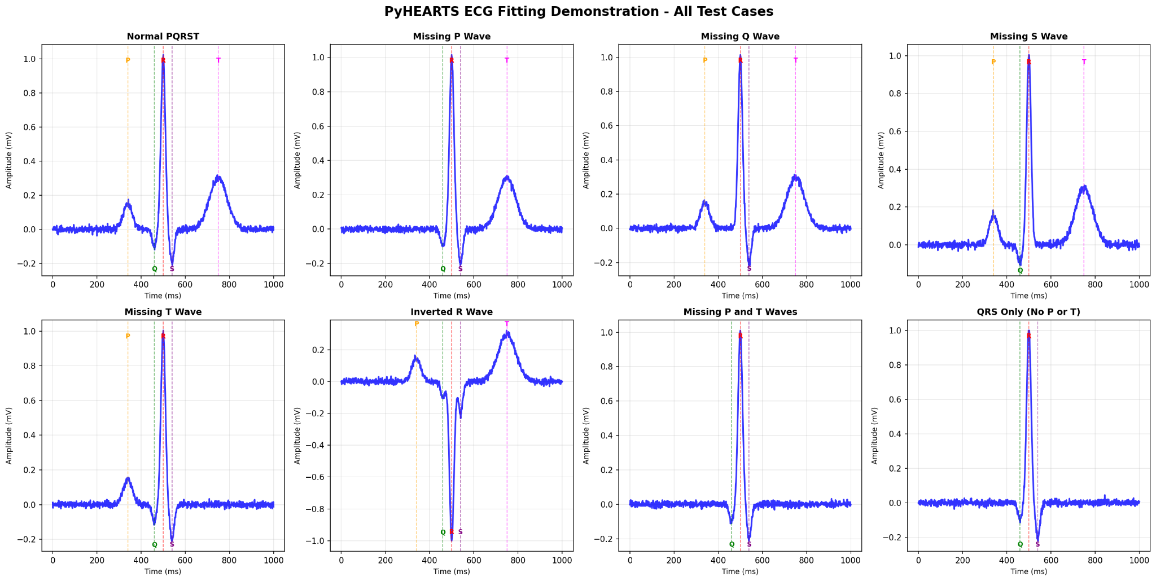
Supplementary Figure 1. PyHEARTS ECG fitting performance across diverse waveform morphologies.

Representative single-beat ECG segments (blue) and fitted P–QRS–T model (red) are shown for eight scenarios: normal PQRST, missing P wave, missing Q wave, missing S wave, missing T wave, inverted R wave, missing P and T waves, and QRS-only (no P or T). Vertical dashed lines mark the detected/fitted fiducial locations for P, Q, R, S and T components (labels at the corresponding markers), illustrating robust handling of absent components and polarity inversion while maintaining accurate localization of the QRS complex.
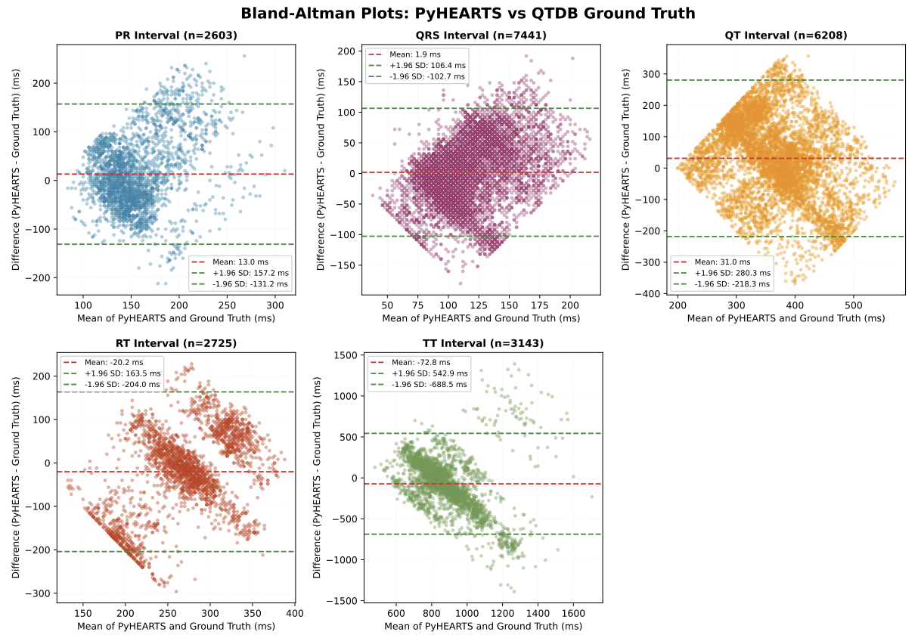
Supplementary Figure 2. Bland-Altman plots comparing PyHEARTS interval measurements against QTDB ground truth annotations.

Agreement between PyHEARTS and manual annotations for PR (n=2,603), QRS (n=7,441), QT (n=6,208), RT (n=2,725), and TT (n=3,143) intervals across 103 subjects. Each plot shows the difference (PyHEARTS − Ground Truth) versus the mean of the two methods, with mean bias (dashed red line) and 95% limits of agreement (dashed green lines, mean ± 1.96 SD). Data from the PhysioNet QT Database (QTDB).

